**Computer Science Project**

**Kaun Banega Crorepati Simulation**



**Made By:**

1. **Ashutosh Purohit**
   1. **Class- XII A**
   2. **Roll No.-**
2. **Dhruv Vyas**
   1. **Class- XII B**
   2. **RollNo.-**

Certificate

This is to certify that Ashutosh Purohit and Dhruv Vyas, students of Class XII A and XII B respectively, Central Academy School, has completed the project titled “Kaun Banega Crorepati Simulation” during the academic year 2017-2018 towards partial fulfilment of credit for the Computer Science Project evaluation of CBSE 2017-18, and submitted a satisfactory report, as compiled in the following pages, under professional supervision.

(.....................................) (.....................................)

Mr. Laxman Singh Bhati Examiner’ Signature

(PGT, Computer Science)

ACKNOWLEDGEMENT

We, **ASHUTOSH PUROHIT** and **DHRUV VYAS** of class XII, are highly grateful to **Mr. Laxman Singh Bhati** for his untiring help and encouragement during the course of project titled “Kaun Banega Crorepati Simulation”. We highly acknowledge, with deepest sense of gratitude and indebtedness, his great coordination and support throughout the course of work. We would also like to express our gratitude to our families, who were always there to help and motivate us.

INDEX

|  |  |  |
| --- | --- | --- |
| S. No. | Title | Pg. No. |
| 1. | Certificate | 1 |
| 2. | Acknowledgement | 2 |
| 3. | Index | 3 |
| 4. | Need for Project | 5 |
| 5. | Hardware and Software Requirements | 6 |
| 6. | Header Files used | 7 |
| 7. | Functions used | 8-9 |
| 8. | Classes used | 10 |
| 9. | Source Code | 11-25 |
| 10. | Output | 26-46 |
| 11. | Bibliography | 47 |

NEED FOR PROJECT

Kaun Banega Crorepati (KBC) simulation system is based on the television show by the same name, hosted by Mr. Amitabh Bachchan. The main objective of this application is to provide its users with an opportunity to play the famous quizzing game at the comfort of their homes on a computer system. The main purpose of this game is to make people learn new things and improve their general knowledge, just by playing a game. This program has two modes: Admin mode, in which one can perform operations on questions, and Player mode, in which one can play the game. The ID for admin mode is '1', and the password is 'kbcadmin'.

HARDWARE AND SOFTWARE REQUIREMENTS

1. Minimum Hardware Requirements
   * 1. Monitor
     2. Keyboard
     3. Mouse
2. Minimum Software Requirements
   * 1. Operating System: Windows XP
     2. Turbo C++
     3. At least 44.0 KB of free space

HEADER FILES USED

|  |  |
| --- | --- |
| **Filename** | **Description** |
| FSTREAM.H | Provides functions for file and We/o handling |
| CONIO.H | Used to create text based UIs |
| STDIO.H | Provides functions with standard We/o capabilities. |
| PROCESS.H | Contains macros for working with threads and processes |
|  |  |
| STRING.H | Contains functions with string handling capabilities |
| TIME.H | To get system time. |
| STDLIB.H | This header defines several general purpose functions |
| CTYPE.H | Contains functions with character handling capabilities |
| KBC.H | Contains user-defined class and functions necessary for the program (User-defined header file) |

Functions USED

1. **Functions in the program**

|  |  |
| --- | --- |
| **Functions** | **Description** |
| void credits() | Know more about programmers. Member function of class admin |
| void rules() | To show rules of game. |
| void showdet() | Used to Display the Details about Prize Money and Rules. |
| void kbcheader() | Funtion to display header menu**.** |
| void showpr() | Function to show amount won by accepting question no. and mode of elimination. |
| void play() | Function to play the game. |

1. **Functions of class "Admin"**

|  |  |
| --- | --- |
| **Function** | **Description** |
| void adminmenu() | Function to perform operations of an admin. Member function of class admin |

1. **Functions of class "Player"**

|  |  |
| --- | --- |
| **Functions** | **Description** |
| void getdata() | To get details of player like name and country. Member function of class player. |
| void playermenu() | Function to display options for a player. Member function of class player. |
| void display() | To show details of player. Member function of class player. |
| void nofplayer() | To store no of players in file. Member function of class player. |

1. **Functions of class "Ques", defined under "KBC.h"**

|  |  |
| --- | --- |
| **Functions** | **Description** |
| int noq() | To get no. of questions in the file. |
| void insques() | Function to insert questions in the file. |
| void showques(int qno) | To show single question from file, by accepting the question no. |
| void showallques() | To show all questions, one by one, from the file. |
| void deleteques(int gid) | To delete questions from the file, by accepting the id of question to be deleted. |
| int chkans(char ch) | To check the answer given by the user, by accepting the user's choice. |

1. **Functions of "KBC.h"**

|  |  |
| --- | --- |
| **Function** | **Description** |
| void dispdate() | To display the current date on screen. |

Classes USED

|  |  |  |  |
| --- | --- | --- | --- |
| Class | Member functions | Data Members | Use |
| Player | getdata()  playermenu()  display()  nofplayer() | Public Members:  int id;  char name[80];  char country[30];  int nop; | To handle the data related to player, like name, country, id, etc. |
| Admin | Adminmenu() | Private members:  int adid;  char name[50];  char password[25]; | To handle the data related to admin, like id, password, etc. |
| Ques | int noq()  void insques()  void showques(int qno)  void showallques()  void deleteques(int gid)  int chkans(char ch) | Public members:  int id  char ques[120]  char opt[4][80]  char copt | To handle the data related to questions and showing them. It is defined under KBC.h header file. |

Source Code

**Program:**

/**************************************************************************

* COMPUTER SCIENCE PROJECT

MADE BY: 1. ASHUTOSH PUROHIT

a.CLASS- XII A

b.ROLL NO.-

2. DHRUV VYAS

a.CLASS- XIIB

b.ROLL NO.-

TITLE - KAUN BANEGA CROREPATI SIMULATION

/****************************************************************************/

/****************************************************************************

* HEADER FILE INCLUSIONS

****************************************************************************/

#include<conio.h>

#include<time.h>

#include<kbc.h>

//'kbc.h' header file made to store classes for Questions

/****************************************************************************

* GLOBAL VARIABLES AND FUNCTION PROTOTYPES

****************************************************************************/

Ques q; //'Ques' class is already defined under 'kbc.h' header file

void credits();

void login();

void play();

void rules();

void showdet();

void kbcheader();

void showpr(int cnt,char cause);

void main(); //main() is used in the user-defined functions, so it has to be declared

/****************************************************************************

* FUNCTION AND CLASS DEFINITIONS

****************************************************************************/

class Player

{

public:

int id;

char name[80];

char country[30];

int nop;

void nofplayer()

{

ifstream fin("player.txt",ios::binary);

fin.read((char*)this,sizeof(*this));

if(!fin)

nop=0;

else if(!fin.eof())

{

nop=1;

while(!fin.eof())

{

fin.read((char*)this,sizeof(*this));

nop++;

}

}

else

nop=0;

fin.close();

}

void getdata()

{

nofplayer();

ofstream fout("player.txt",ios::app);

cout<<"Enter Your Name = ";

gets(name);

cout<<"Enter Your Country = ";

gets(country);

fout.write((char*)this,sizeof(*this));

cout<<"Press Any Key To Continue";

getch();

id=nop+1;

fout.close();

}

void playermenu()

{

char choice;

clrscr();

cout<<"\t\tWELCOME TO KBC PLAYER MENU\n\n";

cout<<"1. Login and Play\n\n";

cout<<"2. Exit\n\n";

cout<<"Enter Your Choice = ";

cin>>choice;

if(choice=='1')

{

getdata();

showdet();

play();

}

else if(choice=='2')

exit(0);

else

{

cout<<"Invalid Choice!!!!";

cout<<"\nPress any key to go back";

kbcheader();

}

}

void display()

{

cout<<"Name: ";

for(int i=0;name[i]!=NULL;i++)

cout<<name[i];

cout<<"\t\t";

cout<<"ID: "<<id<<"\t\t";

cout<<"Country: ";

for(i=0;country[i]!=NULL;i++)

cout<<country[i];

cout<<"\n\n";

}

}p1;

class Admin

{

int adid;

char name[50];

char password[25];

public:

void adminmenu() //Function to perform operations of an admin

{

while(1)

{

clrscr();

char choice,pswd[25];

int id;

cout<<"\t\tWELCOME TO KBC ADMIN MENU\n\n";

cout<<"\t\t1. Admin Login\n\n";

cout<<"\t\t2. Back\n\n";

cout<<"Enter Your Choice = ";

cin>>choice;

if(choice=='1')

{

ifstream fin("ADMIN.txt",ios::binary);

cout<<"Enter Admin ID = ";

cin>>id;

cout<<"Enter Password = ";

gets(pswd);

int found='n';

fin.read((char*)this,sizeof(*this));

if((!strcmp(password,pswd))&&id==adid)

found='f';

else

{

while(!fin.eof())

{

if((!strcmp(password,pswd))&&id==adid)

found='f';

else

fin.read((char*)this,sizeof(*this));

}

if((!strcmp(password,pswd))&&id==adid)

found='f';

}

if(found=='f')

{

while(1)

{

clrscr();

cout<<"Welcome ";

puts(name);

cout<<"\n\nOptions for You: \n";

cout<<"\n1. Insert Questions\n\n";

cout<<"2. Delete Questions\n\n";

cout<<"3. View Questions\n\n";

cout<<"4. Sign Out and Exit\n\n";

cout<<"Enter Your Choice = ";

cin>>choice;

if(choice=='1')

{

char ch;

do

{

q.insques();

cout<<"\nDo you want to enter more(Y/N)? = ";

cin>>ch;

}while(ch=='y'||ch=='Y');

}

else if(choice=='2')

{

int gid;

clrscr();

cout<<"Enter ID of Question to be deleted = ";

cin>>gid;

q.deleteques(gid);

getch();

}

else if(choice=='3')

{

cout<<"Displaying all questions...\n";

system("pause");

q.showallques();

}

else

{

cout<<"Moving back to KBC Header...\n";

system("pause");

kbcheader();

}

}

}

else

{

cout<<"Sorry, No User Found!!!";

cout<<"Moving Back To KBC Header\n";

getch();

kbcheader();

}

fin.close();

}

else if(choice=='2')

break;

else

cout<<"Wrong Choice!!!";

}

clrscr();

}

int getid() //Function to get the ID of an admin to check

{

return adid;

}

}a1,ar;

void credits() //Function to display credits of this project

{

clrscr();

cout<<"\n\t\tC++ Project: Kaun Banega Crorepati Simulation\n\n";

cout<<"MADE BY: \n\n";

cout<<"1. NAME: ASHUTOSH PUROHIT\n";

cout<<"CLASS: XII A\n";

cout<<"ROLL NO.: \n\n\n";

cout<<"2. NAME: DHRUV VYAS\n";

cout<<"CLASS: XII B\n";

cout<<"ROLL NO.: \n\n\n";

}

void rules() //Function to display the rules

{

cout<<"\n\t\tRULES OF THE GAME\n";

cout<<"\n1. There are 15 questions in this game, and for answering wach, you'll win the amount corresponding to that question.\n";

cout<<"\n2. If you answered any question incorrectly, then you'll lose the game.\n";

cout<<"\n3. There are two checkpoints in the game, 1st at Rs. 10,000, and the other at 3,20,000. Once you pass the checkpoint, you'll definitely win the mentioned amount.\n";

cout<<"\n4. If you quit the game, you'll win the previous indicated amount\n";

cout<<"\n\nPress Any Key To Continue";

getch();

clrscr();

}

void showdet() *//Used to Display the Details about Prize Money and Rules*

*{*

clrscr();

cout<<"\n\n\t\tWELCOME TO KAUN BANEGA CROREPATI!!!!\n";

cout<<"Prize Money:";

cout<<"\t15. 1,00,00,000\n";

cout<<"\t\t14. 50,00,000\n";

cout<<"\t\t13. 25,00,000\n";

cout<<"\t\t12. 12,50,000\n";

cout<<"\t\t11. 6,40,000\n";

cout<<"\t\t10. 3,20,000 (Second Checkpoint)\n";

cout<<"\t\t09. 1,60,000\n";

cout<<"\t\t08. 80,000\n";

cout<<"\t\t07. 40,000\n";

cout<<"\t\t06. 20,000\n";

cout<<"\t\t05. 10,000 (First Checkpoint)\n";

cout<<"\t\t04. 5,000\n";

cout<<"\t\t03. 3,000\n";

cout<<"\t\t02. 2,000\n";

cout<<"\t\t01. 1,000\n";

for(int i=0;i<80;i++)

cout<<"*";

cout<<"\n\t\tPress Any Key To Continue\n";

getch();

clrscr();

rules();

}

void kbcheader() //Function to display the Header Menu

{

char choice;

int n;

while(1)

{

clrscr();

cout<<"\n\t\tKBC HEADER MENU\n\n";

cout<<"\t\t1. Admin Menu\n\n";

cout<<"\t\t2. Player Menu\n\n";

cout<<"\t\t3. Exit\n\n";

cout<<"Enter your choice = ";

cin>>choice;

if(choice=='1')

{

ar.adminmenu();

}

else if(choice=='2')

p1.playermenu();

else if(choice=='3')

exit(0);

else

{

cout<<"Invalid Choice!!!";

cout<<"\nReturning Back!!!";

getch();

main();

}

}

};

void showpr(int cnt,char cause) //Function to show amount won by accepting question no. and mode of elimination

{

if(cause=='N')

{

switch(cnt)

{

case 0: cout<<"\nSorry, You won Nothing!!!\n";

break;

case 1: cout<<"\nYou Have Won Rs. 1,000!!!\n";

break;

case 2: cout<<"\nYou Have Won Rs. 2,000!!!\n";

break;

case 3: cout<<"\nYou Have Won Rs. 3,000!!!\n";

break;

case 4: cout<<"\nYou Have Won Rs. 5,000!!!\n";

break;

case 5: cout<<"\nYou Have Won Rs. 10,000!!!\n";

cout<<"\nYou Have Cleared the First Checkpoint!!!\n";

break;

case 6: cout<<"\nYou Have Won Rs. 20,000!!!\n";

break;

case 7: cout<<"\nYou Have Won Rs. 40,000!!!\n";

break;

case 8: cout<<"\nYou Have Won Rs. 80,000!!!\n";

break;

case 9: cout<<"\nYou Have Won Rs. 1,60,000!!!\n";

break;

case 10: cout<<"\nYou Have Won Rs. 3,20,000!!!\n";

cout<<"\nYou Have Cleared the Second Checkpoint!!!\n";

break;

case 11: cout<<"\nYou Have Won Rs. 6,40,000!!!\n";

break;

case 12: cout<<"\nYou Have Won Rs. 12,50,000!!!\n";

break;

case 13: cout<<"\nYou Have Won Rs. 25,00,000!!!\n";

break;

case 14: cout<<"\nYou Have Won Rs. 50,00,000!!!\n";

break;

case 15: cout<<"\nYou Have Won Rs. 1,00,00,000!!!\n";

break;

}

}

else if(cause=='Q')

{

switch(cnt)

{

case 0: cout<<"Nothing.\n";

break;

case 1: cout<<"Rs. 1,000!!!\n";

break;

case 2: cout<<"Rs. 2,000!!!\n";

break;

case 3: cout<<"Rs. 3,000!!!\n";

break;

case 4: cout<<"Rs. 5,000!!!\n";

break;

case 5: cout<<"Rs. 10,000!!!\n";

break;

case 6: cout<<"Rs. 20,000!!!\n";

break;

case 7: cout<<"Rs. 40,000!!!\n";

break;

case 8: cout<<"Rs. 80,000!!!\n";

break;

case 9: cout<<"Rs. 1,60,000!!!\n";

break;

case 10: cout<<"Rs. 3,20,000!!!\n";

break;

case 11: cout<<"Rs. 6,40,000!!!\n";

break;

case 12: cout<<"Rs. 12,50,000!!!\n";

break;

case 13: cout<<"Rs. 25,00,000!!!\n";

break;

case 14: cout<<"Rs. 50,00,000!!!\n";

break;

};

}

else if(cause=='E')

{

if(cnt<5)

cout<<"\nSorry, You won Nothing!!!\n";

else if(cnt<10)

cout<<"\nYou Have Won Rs. 10,000!!!\n";

else

cout<<"\nYou Have Won Rs. 3,20,000!!!\n";

}

}

void play() //Function to play the game

{

clrscr();

srand(time(NULL));

ifstream fin("KBC.txt",ios::binary);

char ch='y',cause='N';

int qp[15],a;

int count=0;

for(int i=0;i<15;i++)

{

a=rand()%q.noq();

for(int j=0;j<i;j++)

if(qp[j]==a)

break;

if(i==j)

qp[i]=a;

else

i--;

}

while(count<15)

{

fin.seekg(0);

p1.display();

dispdate();

int n=qp[count];

fin.read((char*)&q,sizeof(q));

while(!fin.eof())

{

if((n+1)==q.id)

break;

else

fin.read((char*)&q,sizeof(q));

}

q.showques(count);

cout<<"Enter Your Choice('Q' to Quit) = ";

cin>>ch;

if(q.chkans(ch))

showpr(++count,cause);

else if(ch=='Q')

{

cause='Q';

cout<<"\nSo, ";

for(int i=0;p1.name[i]!=NULL;i++)

cout<<p1.name[i];

cout<<" has decided to quit the game, and has won ";

showpr(count,cause);

cout<<"\nThank You for Playing Kaun Banega Crorepati. Have a good day ahead!!!";

break;

}

else

{

cause='E';

cout<<"\nSorry, Better Luck Next Time!!!!\n";

cout<<"\nThank You For Playing Kaun Banega Crorepati, Have a Good Day Ahead";

showpr(count,cause);

break;

}

cout<<"\nPress Any Key To Continue";

getch();

clrscr();

}

if(count==15)

{

cout<<"\n\t\tCONGRATULATIONS!!!! YOU'VE BECOME A CROREPATI\n\t";

cout<<"Thank You for Playing Kaun banega Crorepati. Have a great day ahead!!!\n\t\t";

system("pause");

getch();

credits();

}

getch();

}

void main()

{

clrscr();

kbcheader();

getch();

}

**Header File:**

#include<fstream.h>

#include<stdio.h>

#include<stdlib.h>

#include<dos.h>

#include<string.h>

static int k;

class Ques

{

public:

int id;

char ques[120];

char opt[4][80];

char copt;

int noq()

{

int noq=0;

ifstream fin("KBC.txt",ios::binary);

if(!fin)

noq=0;

else

{

fin.read((char*)this,sizeof(*this));

while(!fin.eof())

{

noq++;

fin.read((char*)this,sizeof(*this));

}

}

fin.close();

return noq;

}

void insques()

{

ofstream fout("KBC.txt",ios::app|ios::binary);

id=noq();

++id;

cout<<"Enter Question = ";

gets(ques);

k=strlen(ques);

k++;

ques[k]='\n';

for(int i=0;i<4;i++)

{

cout<<"Enter Option "<<i+1<<" = ";

gets(opt[i]);

}

cout<<"Enter Correct Option = ";

cin>>copt;

fout.write((char*)this,sizeof(*this));

cout<<"Question Inserted!!!\n";

system("pause");

fout.close();

}

void showques(int qno)

{

k=strlen(ques);

k++;

for(int i=0;i<=k;i++)

{

if(ques[i]=='.'&&ques[i-1]=='Q')

cout<<ques[i]<<++qno;

else

cout<<ques[i];

}

cout<<"\n\n";

for(i=0;i<4;i++)

puts(opt[i]);

cout<<endl;

}

void showallques()

{

int i=0;

ifstream fin("KBC.txt",ios::binary);

fin.read((char*)this,sizeof(*this));

while(!fin.eof())

{

clrscr();

showques(i);

getch();

fin.read((char*)this,sizeof(*this));

i++;

}

fin.close();

}

void deleteques(int gid)

{

ifstream fin("KBC.txt",ios::binary);

ofstream fout("temp.txt",ios::binary);

fin.read((char*)this,sizeof(*this));

while(!fin.eof())

{

if(id!=gid)

fout.write((char*)this,sizeof(*this));

fin.read((char*)this,sizeof(*this));

}

fout.close();

fin.close();

remove("KBC.txt");

rename("temp.txt","KBC.txt");

cout<<"Press any key to view questions...";

getch();

clrscr();

showallques();

}

int chkans(char ch)

{

if(ch==copt||ch==(copt+32))

return 1;

else

return 0;

}

};

void dispdate()

{

struct date d1;

getdate(&d1);

int ch=d1.da_day,ch1=d1.da_mon;

char mon[15];

switch (ch1)

{

case 1: strcpy(mon,"January");

break;

case 2: strcpy(mon,"February");

break;

case 3: strcpy(mon,"March");

break;

case 4: strcpy(mon,"April");

break;

case 5: strcpy(mon,"May");

break;

case 6: strcpy(mon,"June");

break;

case 7: strcpy(mon,"July");

break;

case 8: strcpy(mon,"August");

break;

case 9: strcpy(mon,"September");

break;

case 10: strcpy(mon,"October");

break;

case 11: strcpy(mon,"November");

break;

case 12: strcpy(mon,"December");

break;

};

cout<<ch<<" "<<mon<<", "<<d1.da_year<<"\n\n";

}

OUTPUT

**Welcome to KBC, Let’s Play!!!**

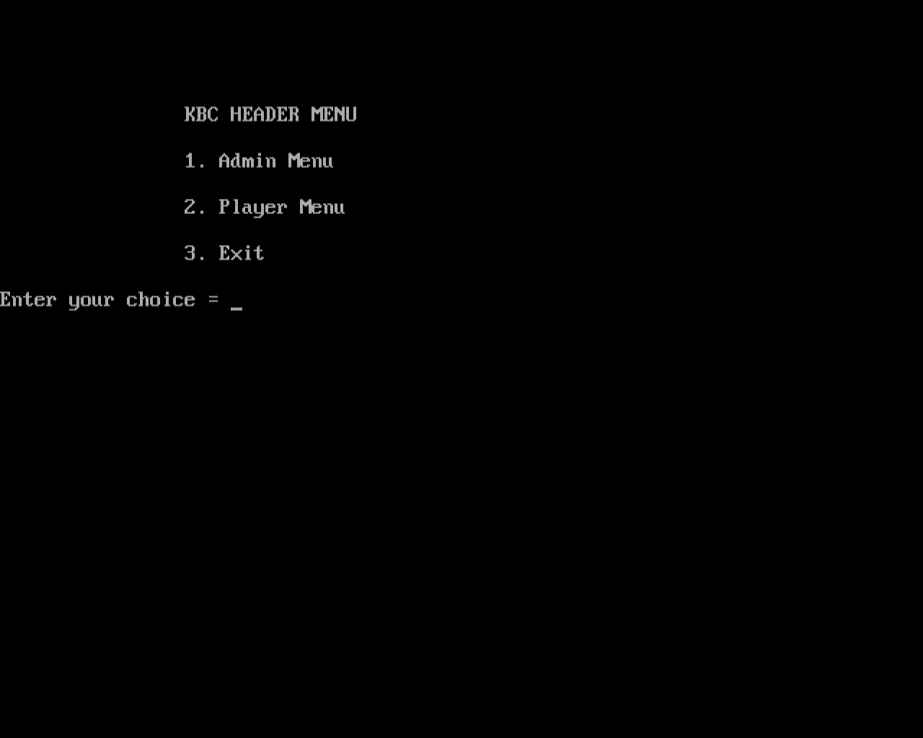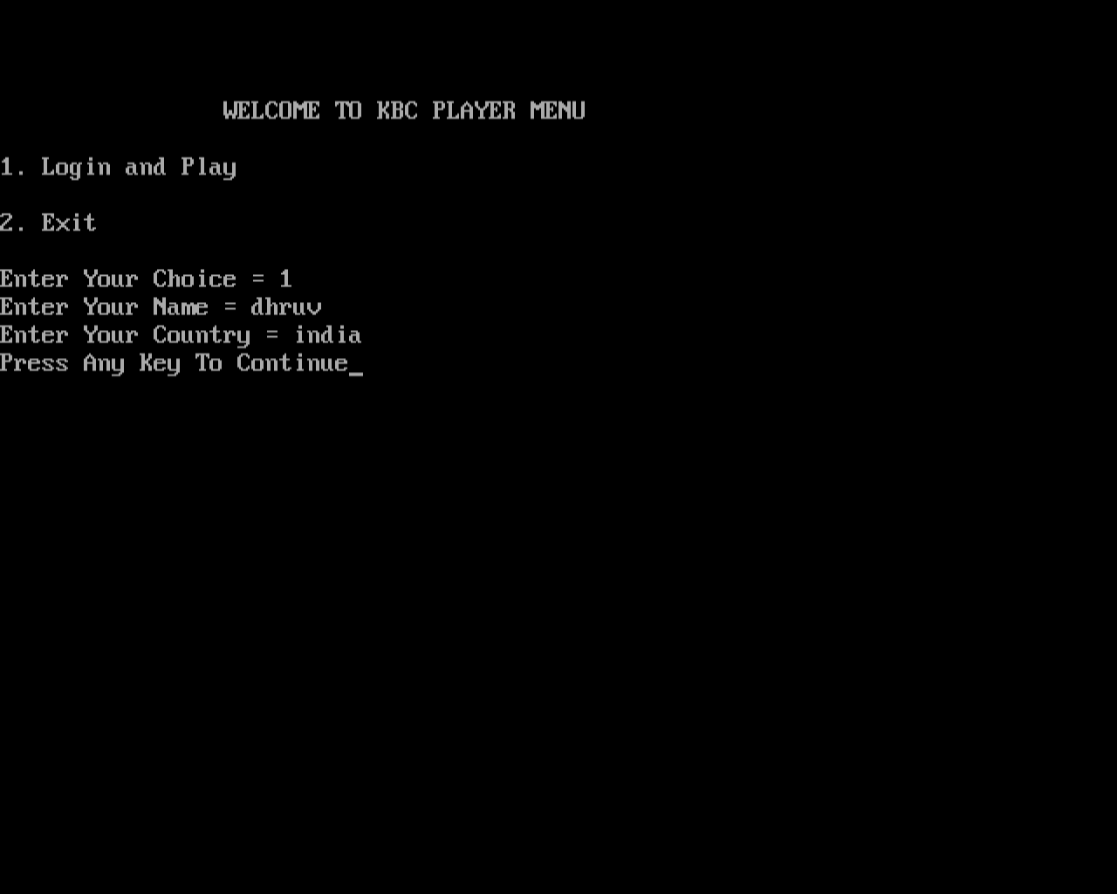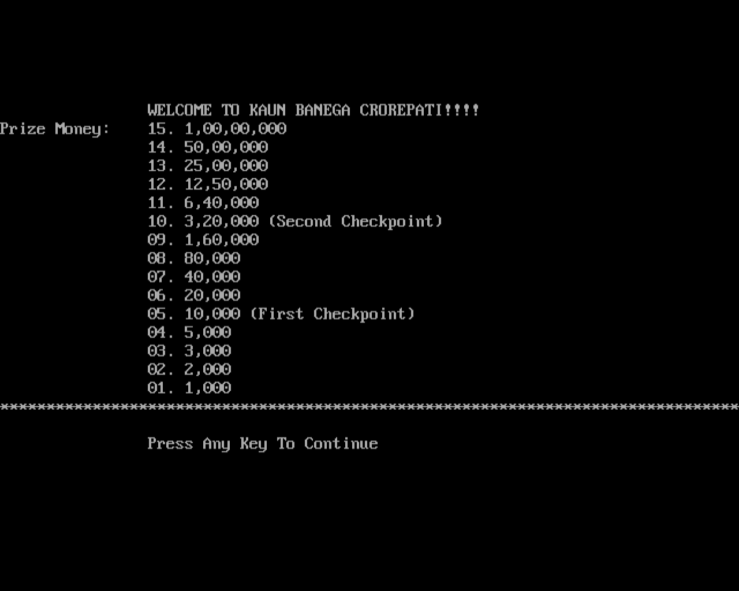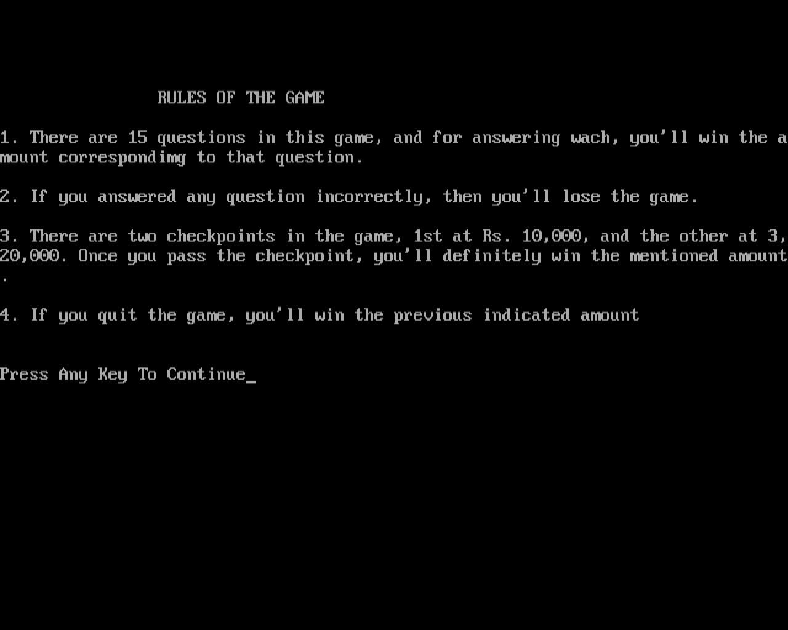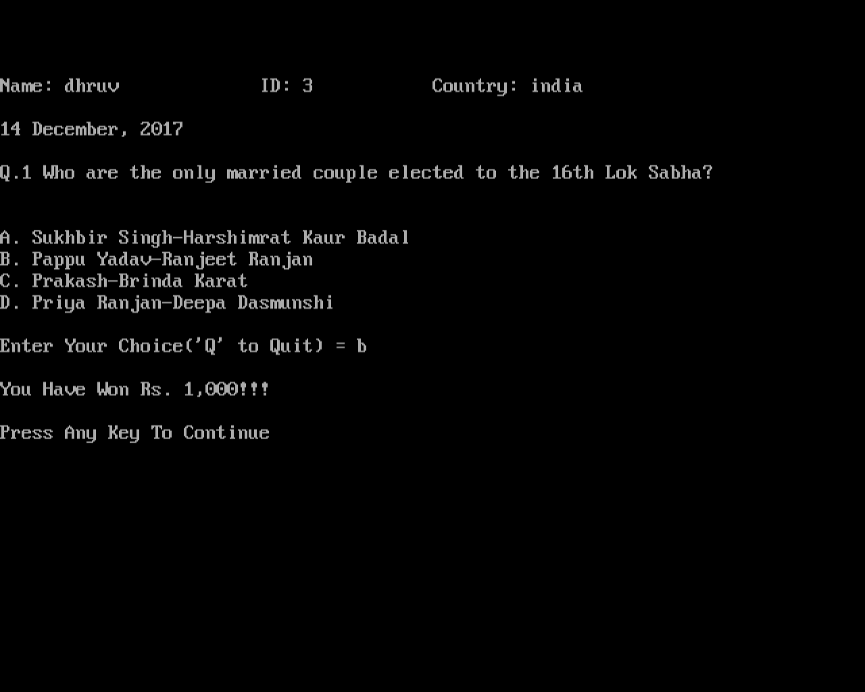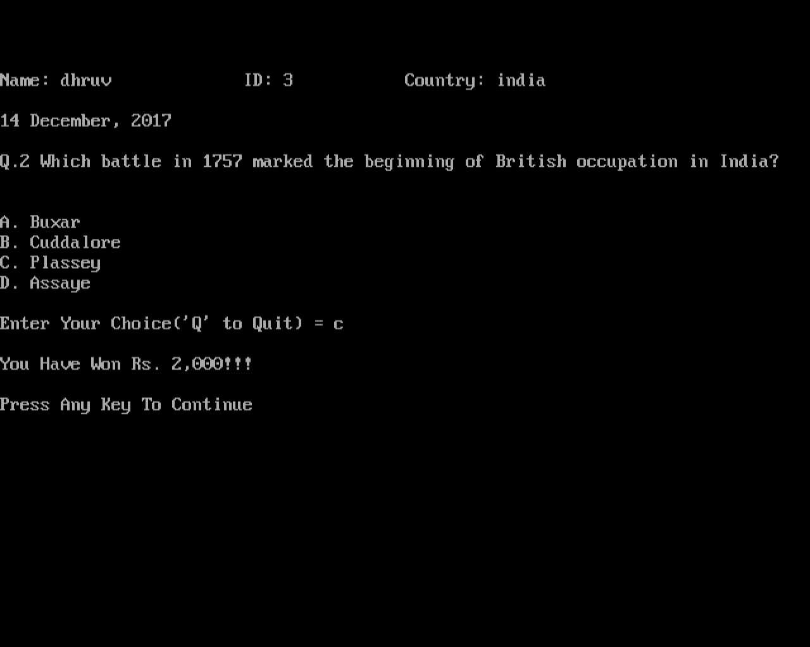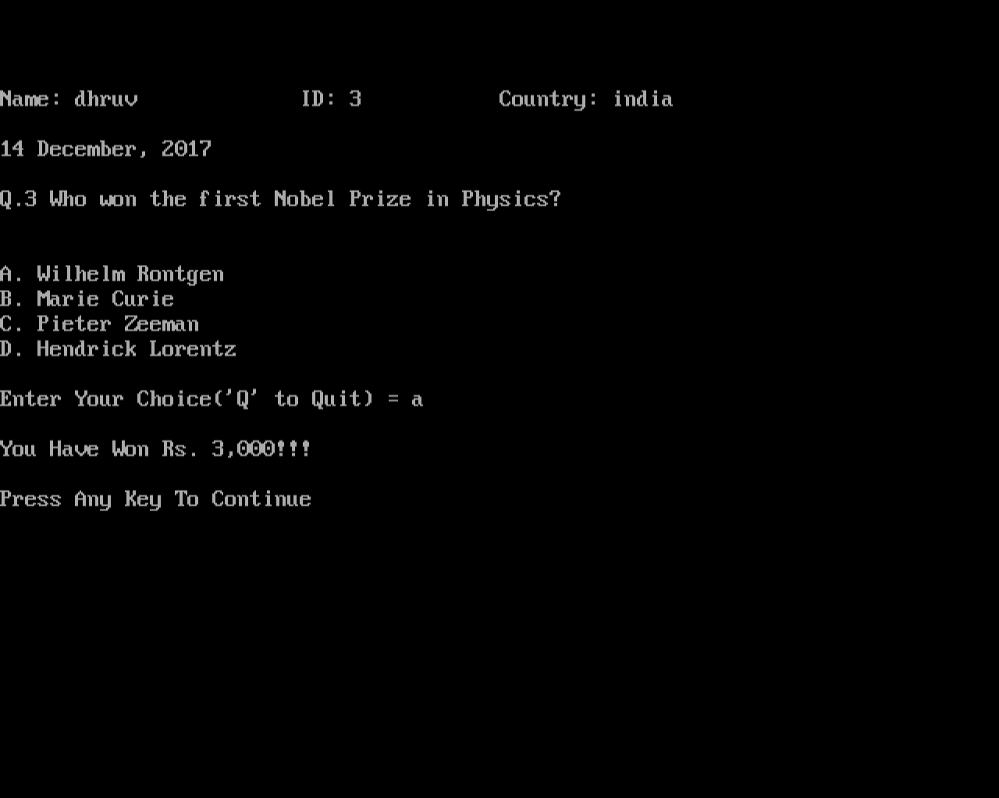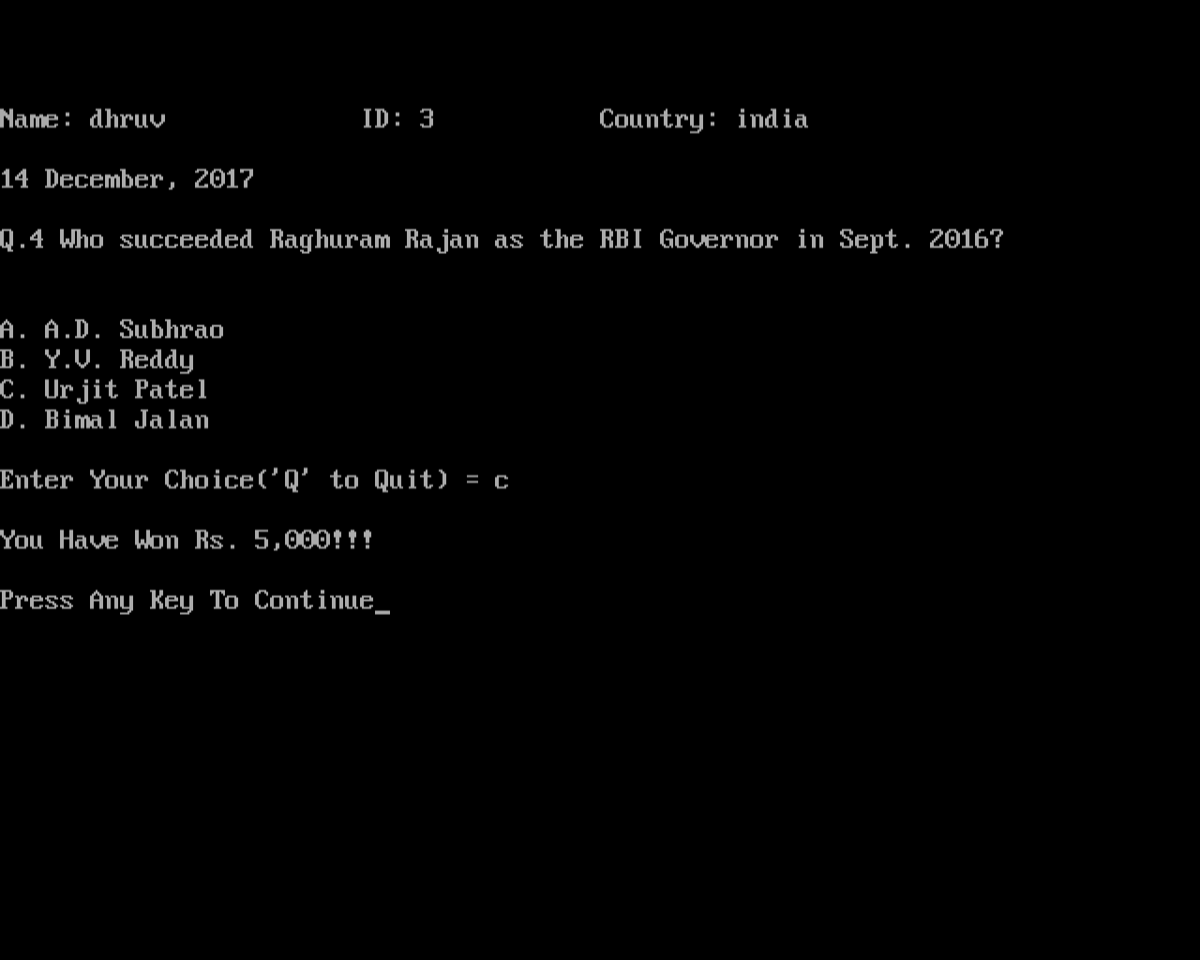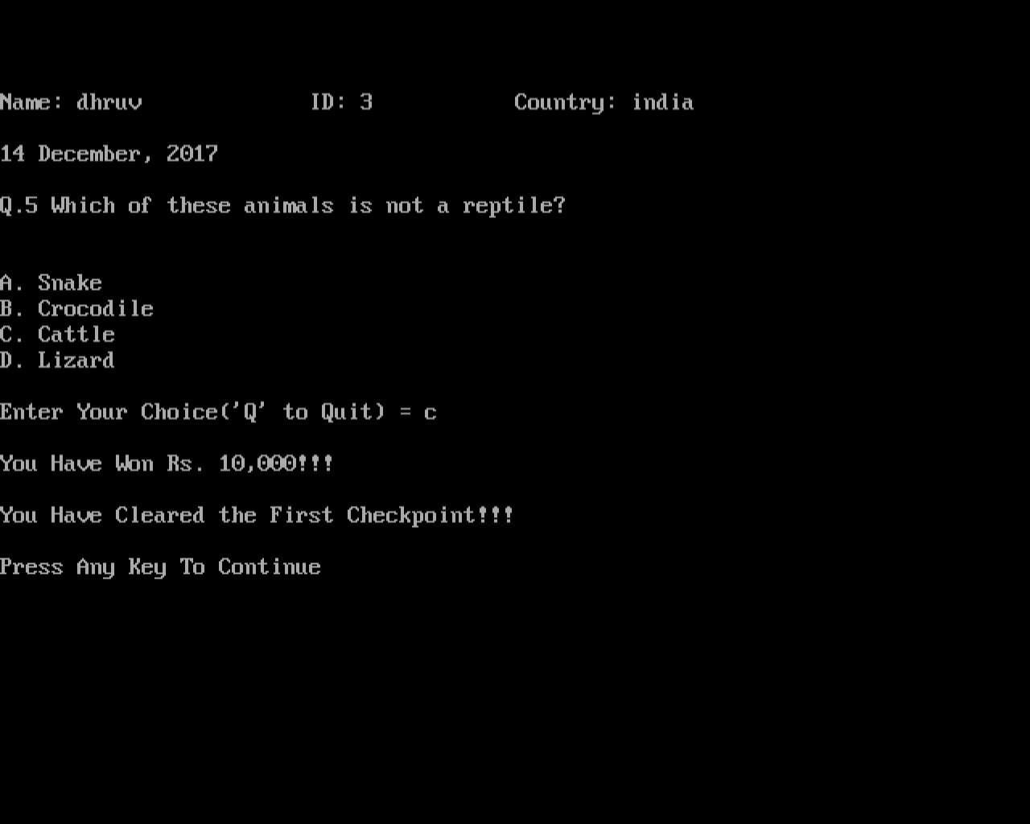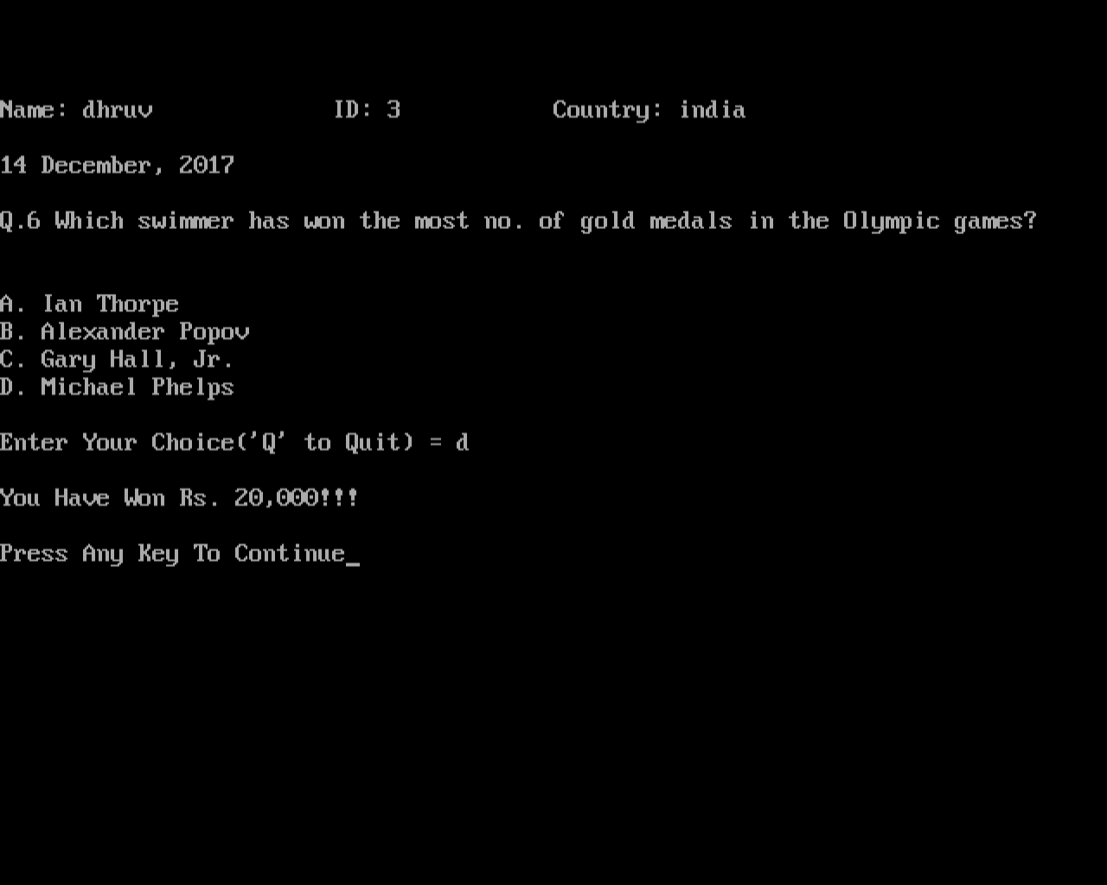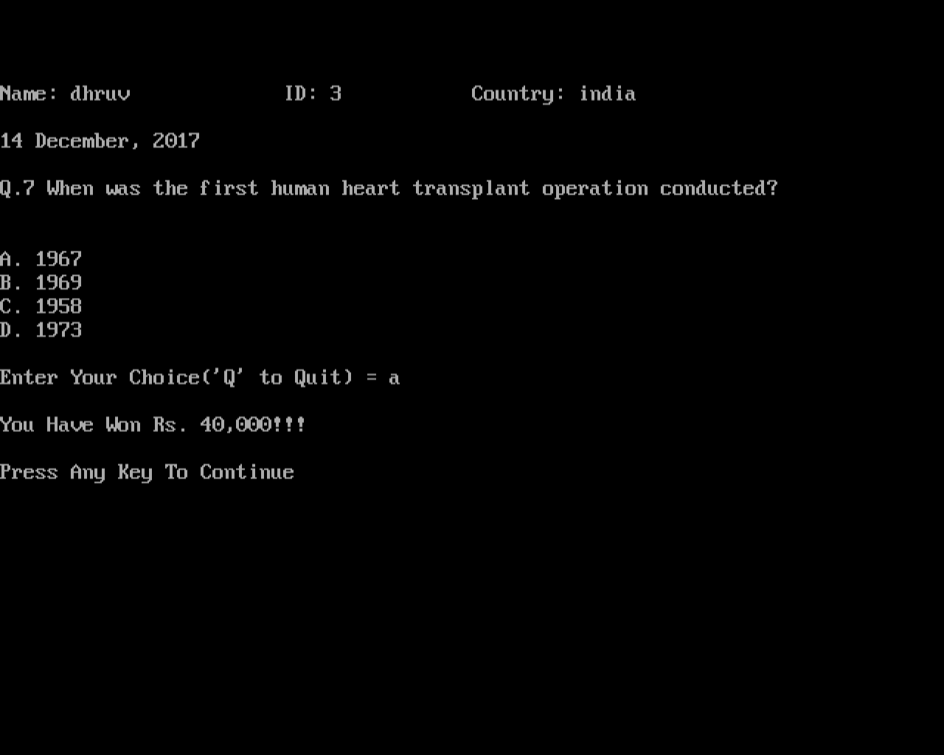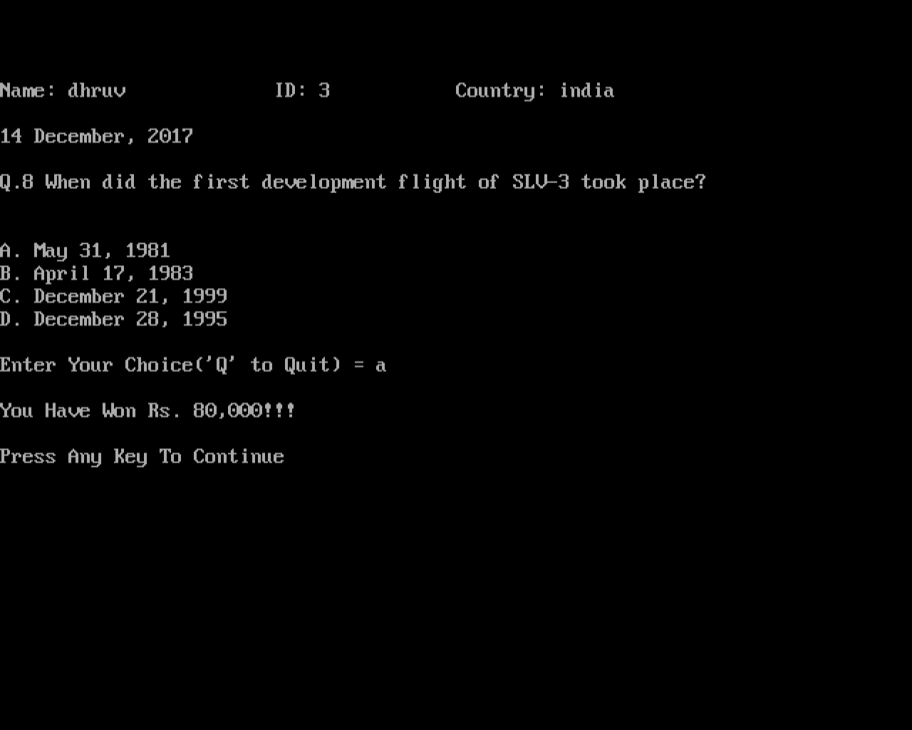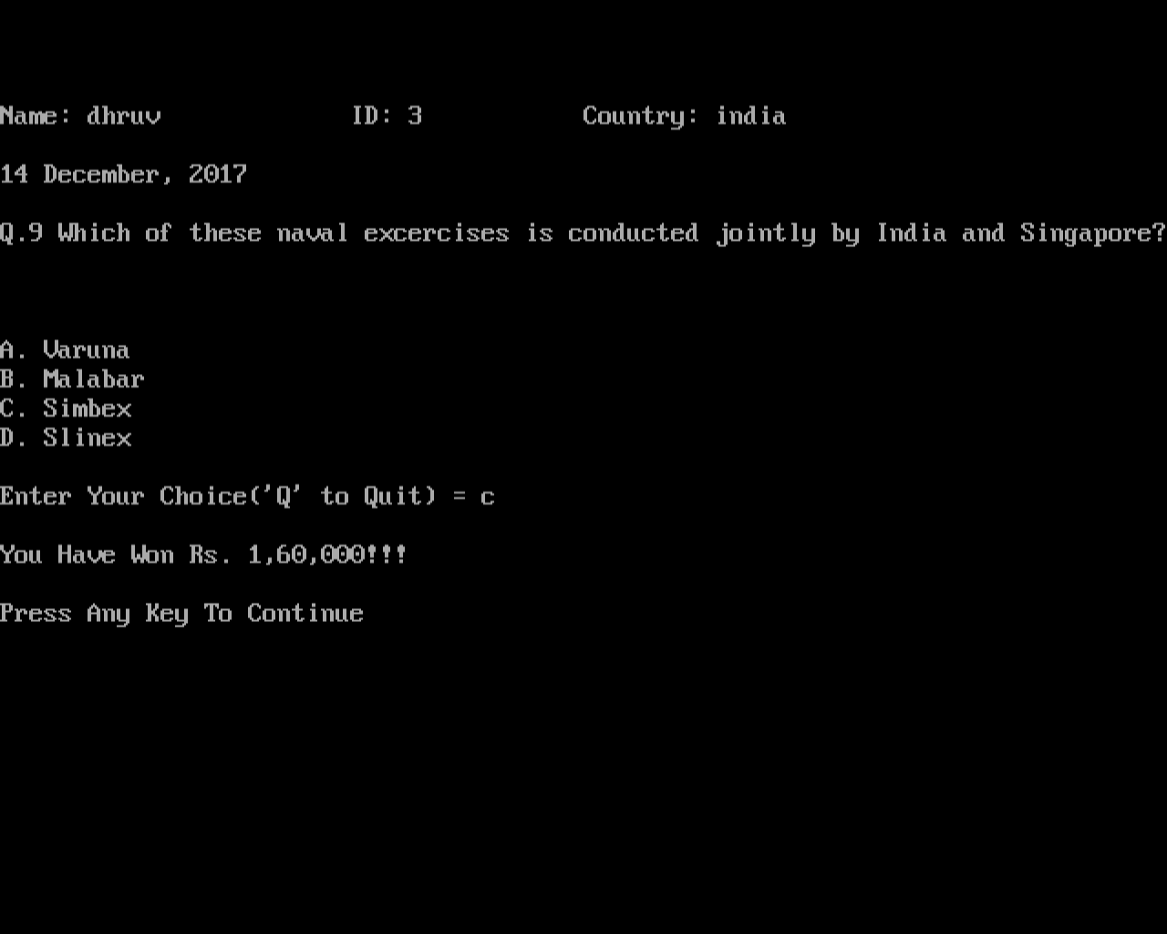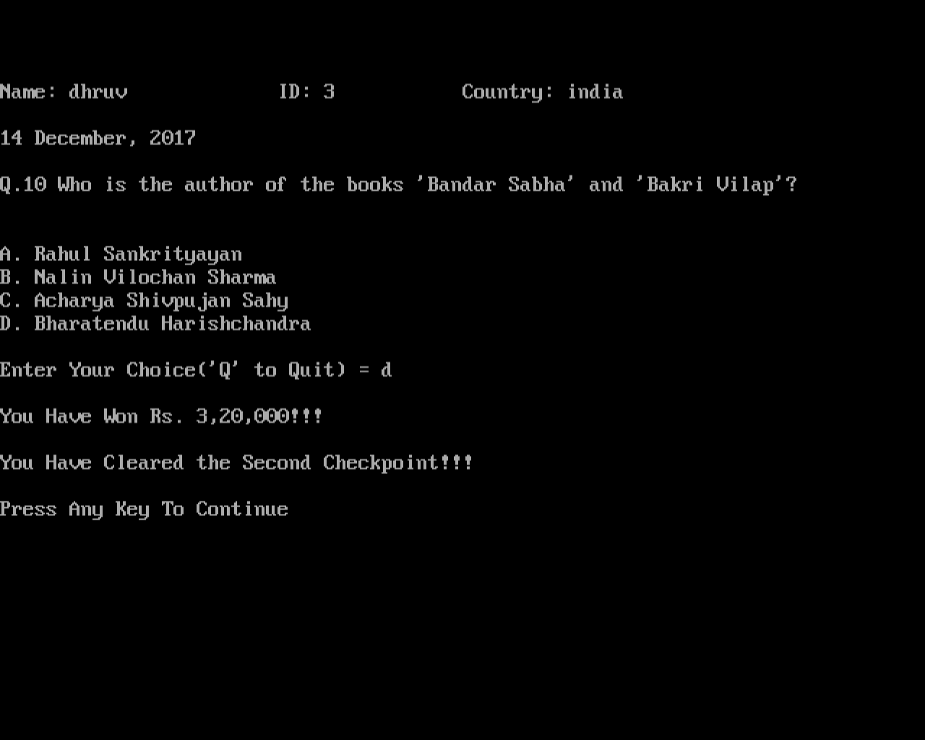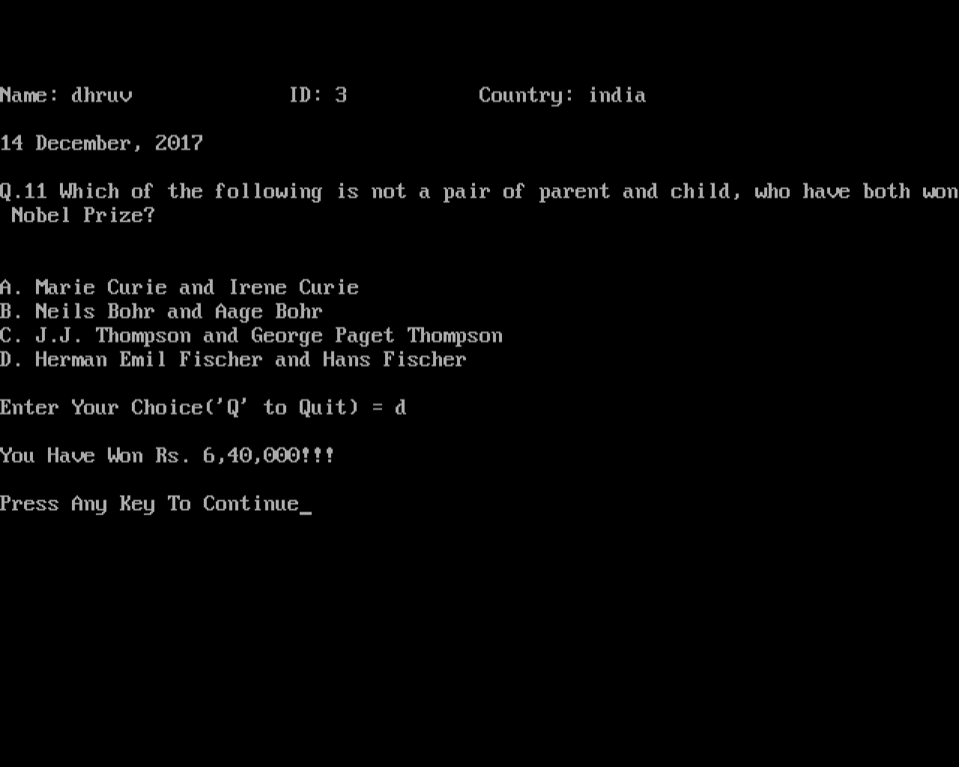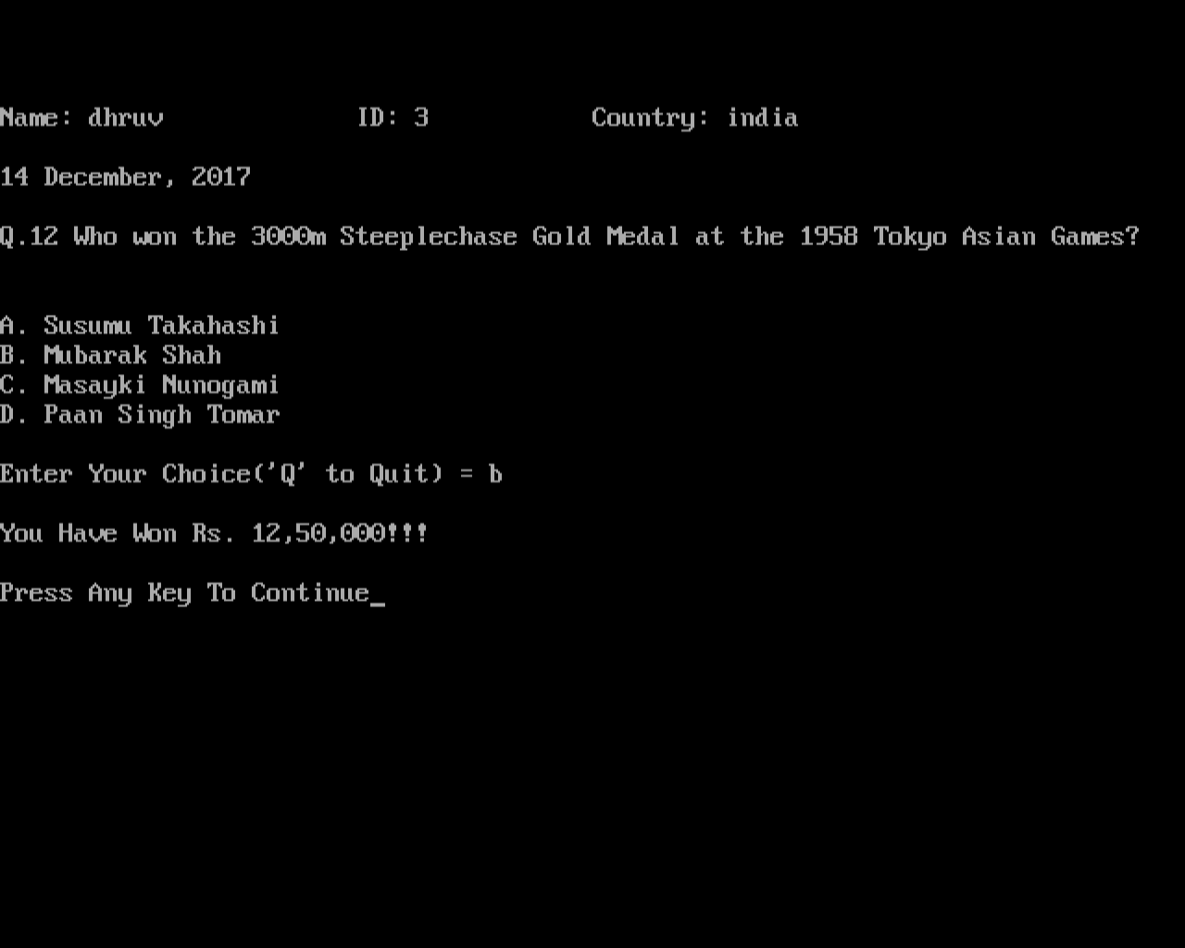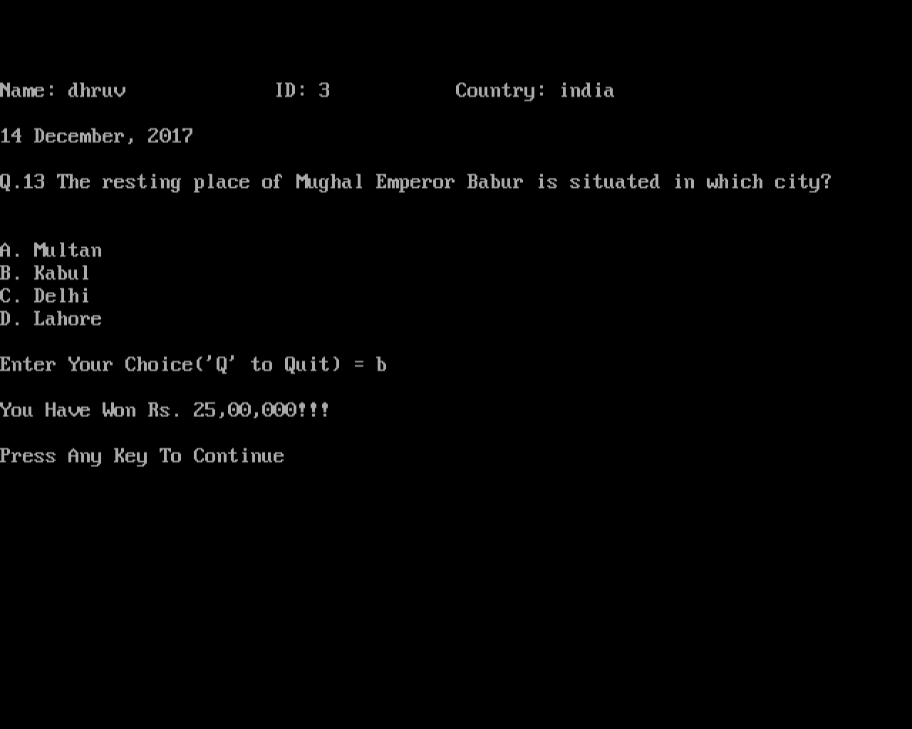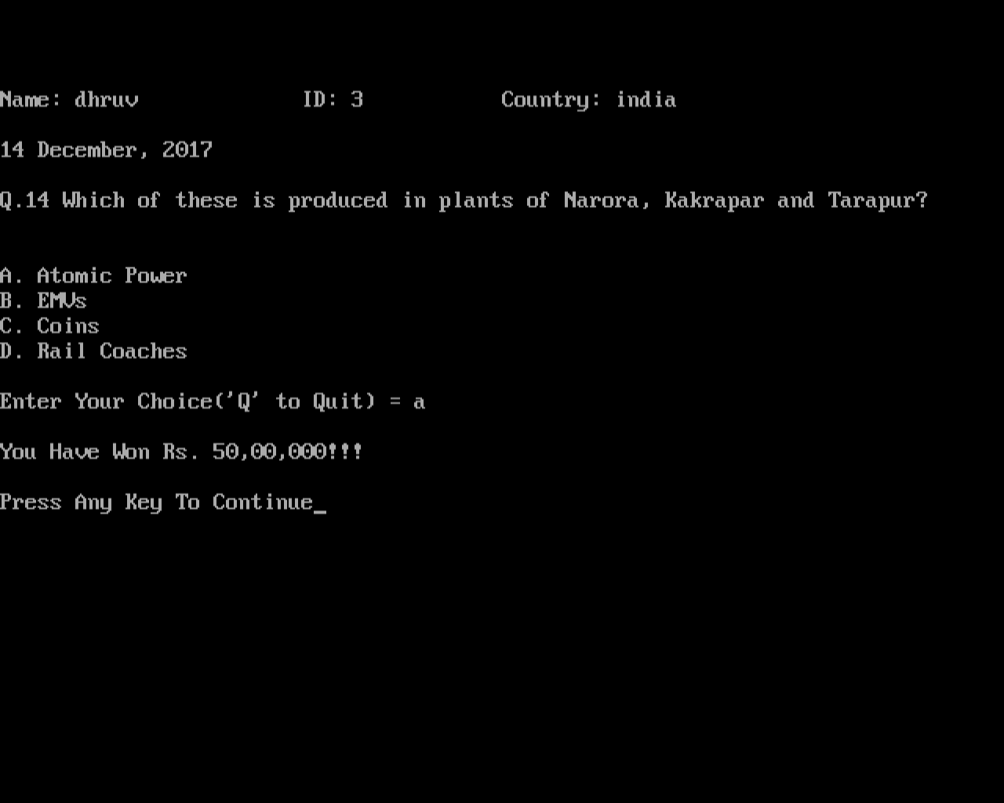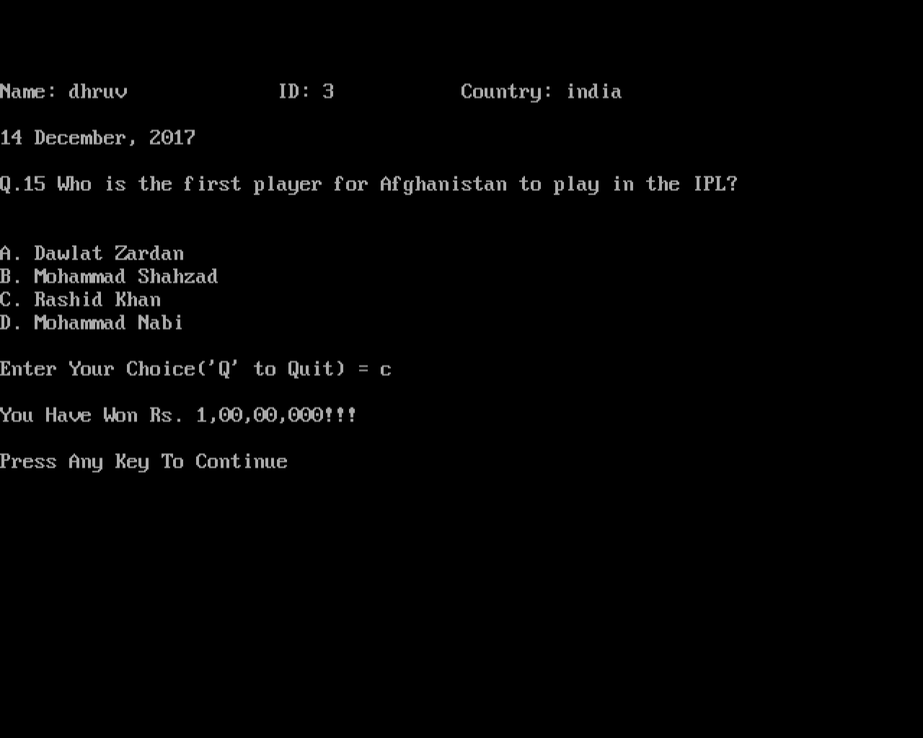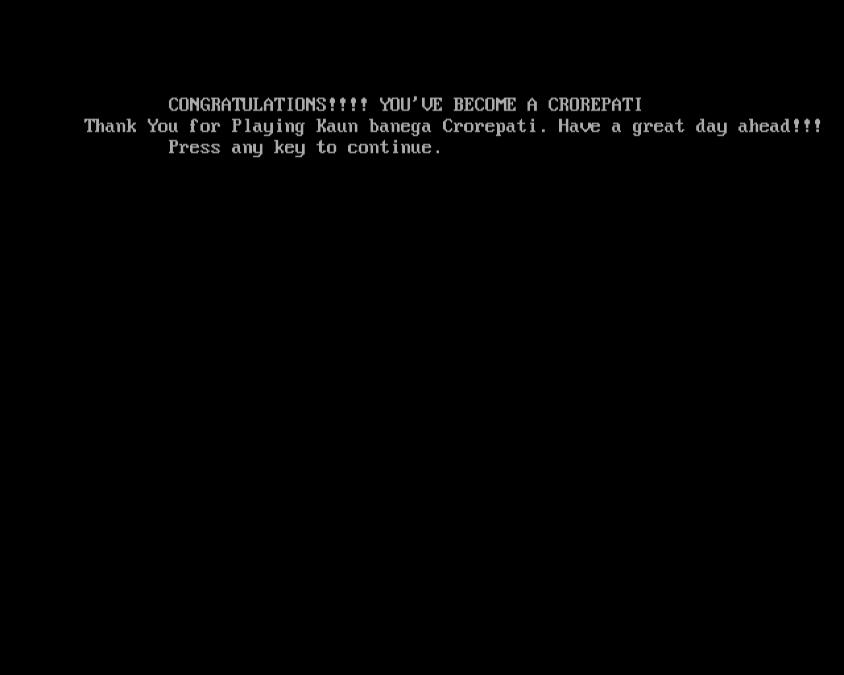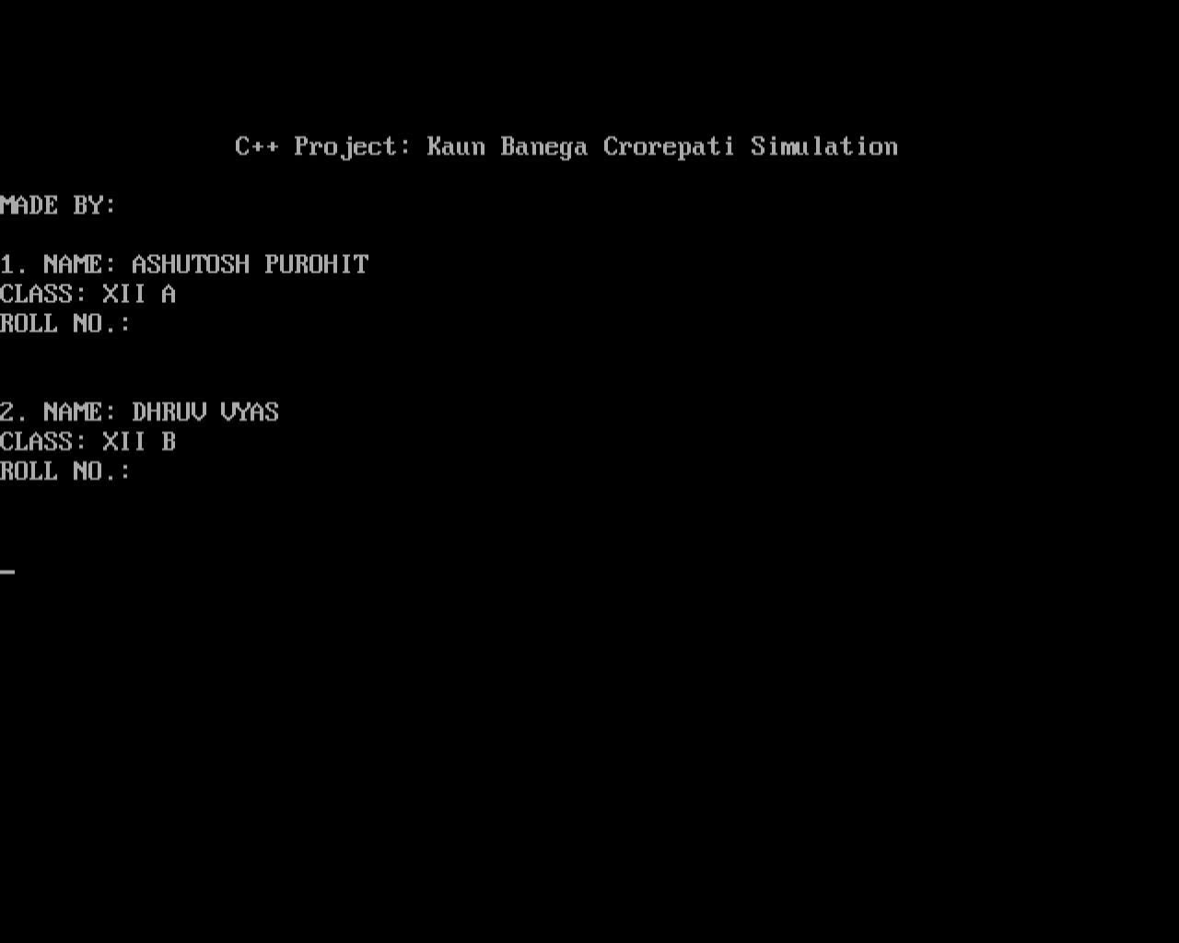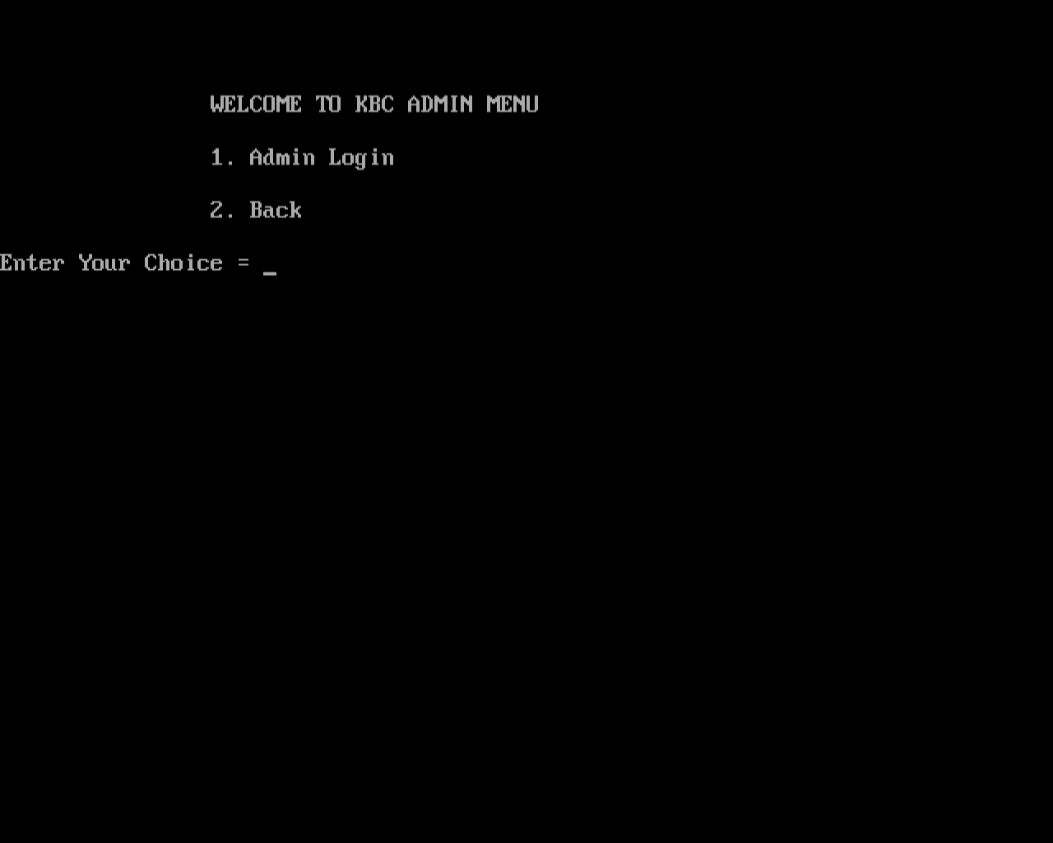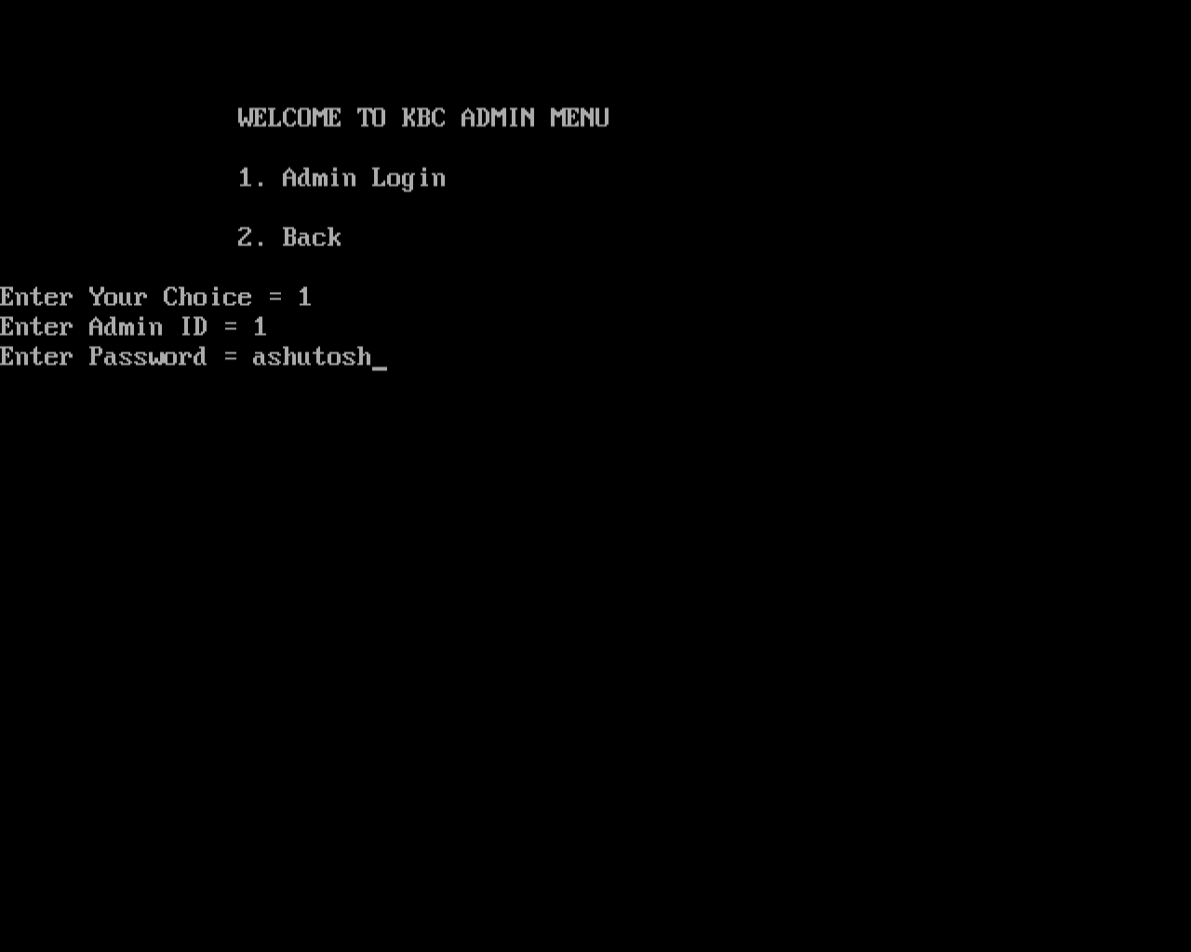

* 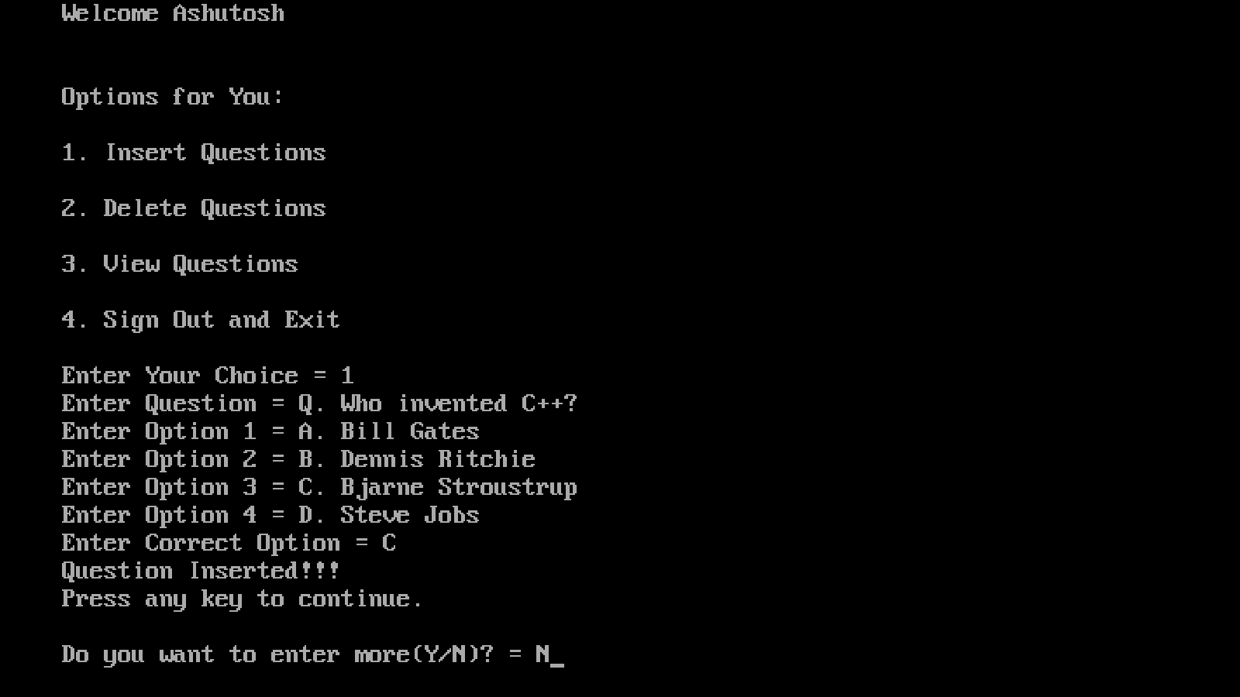
* 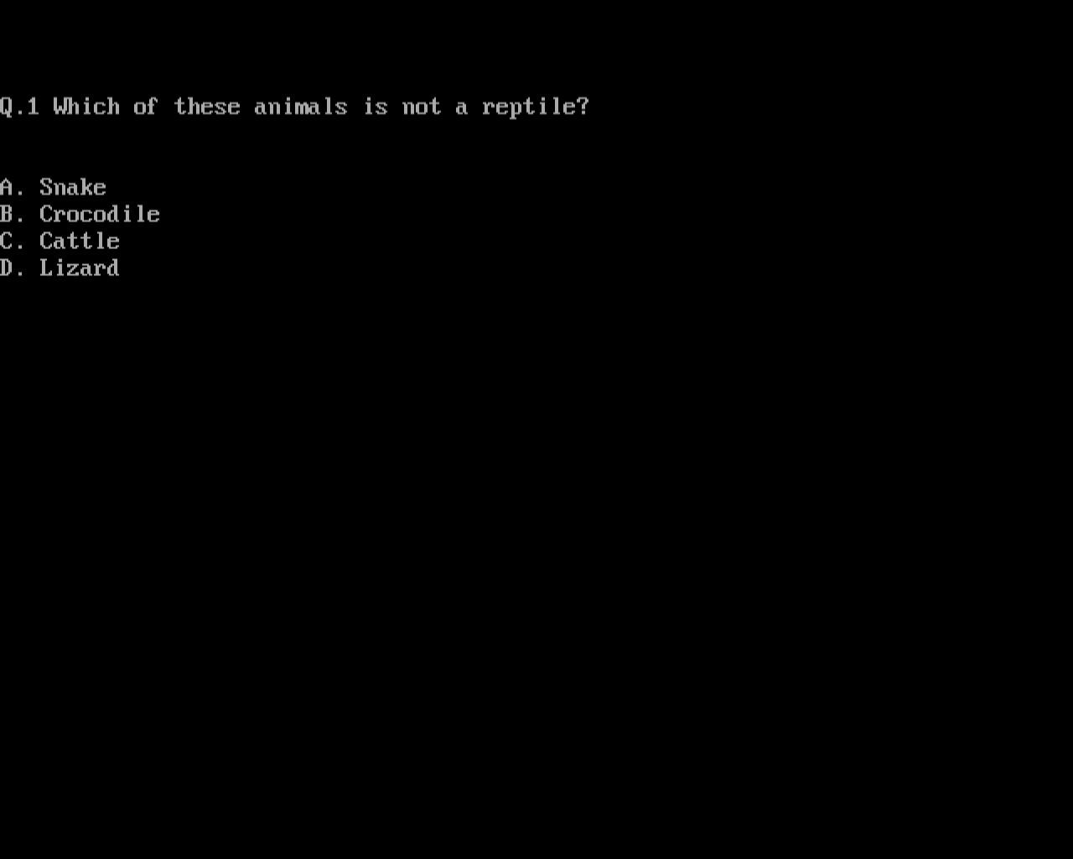
* 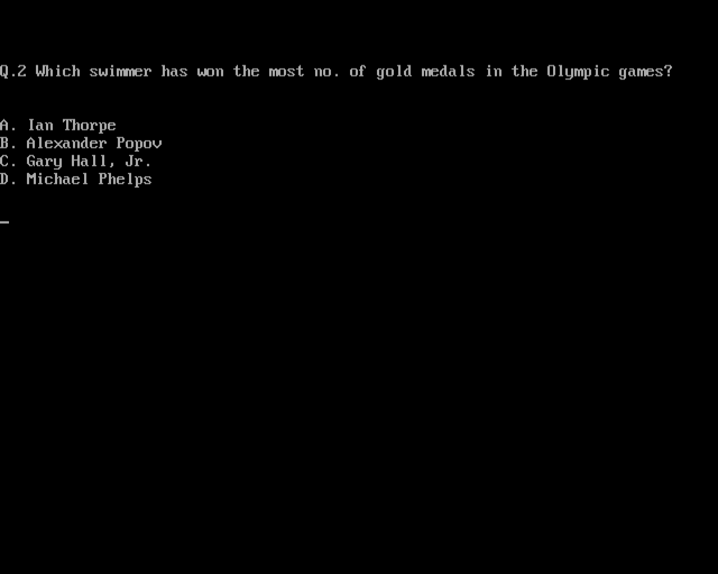
* 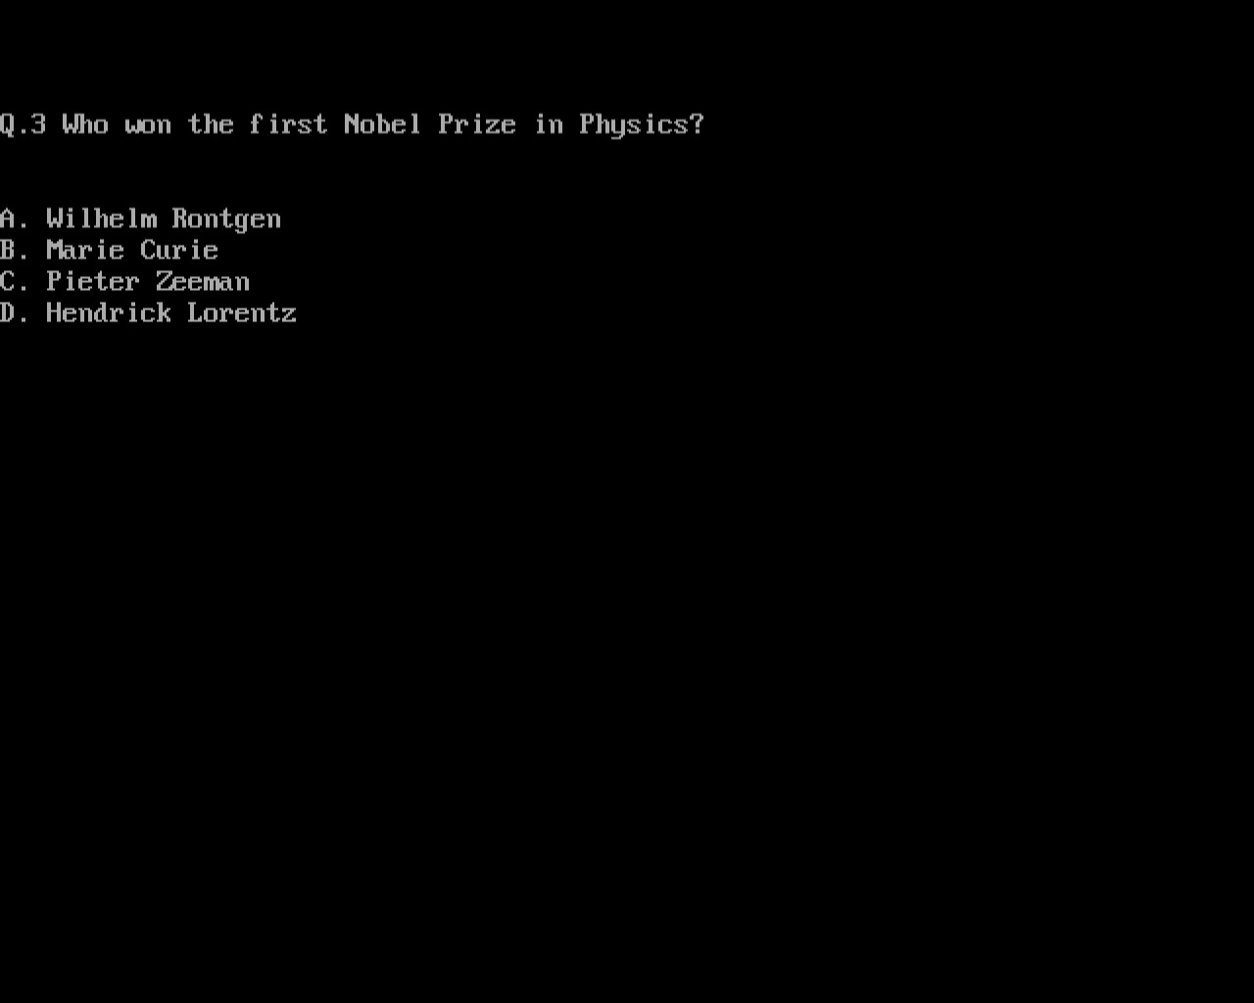
* 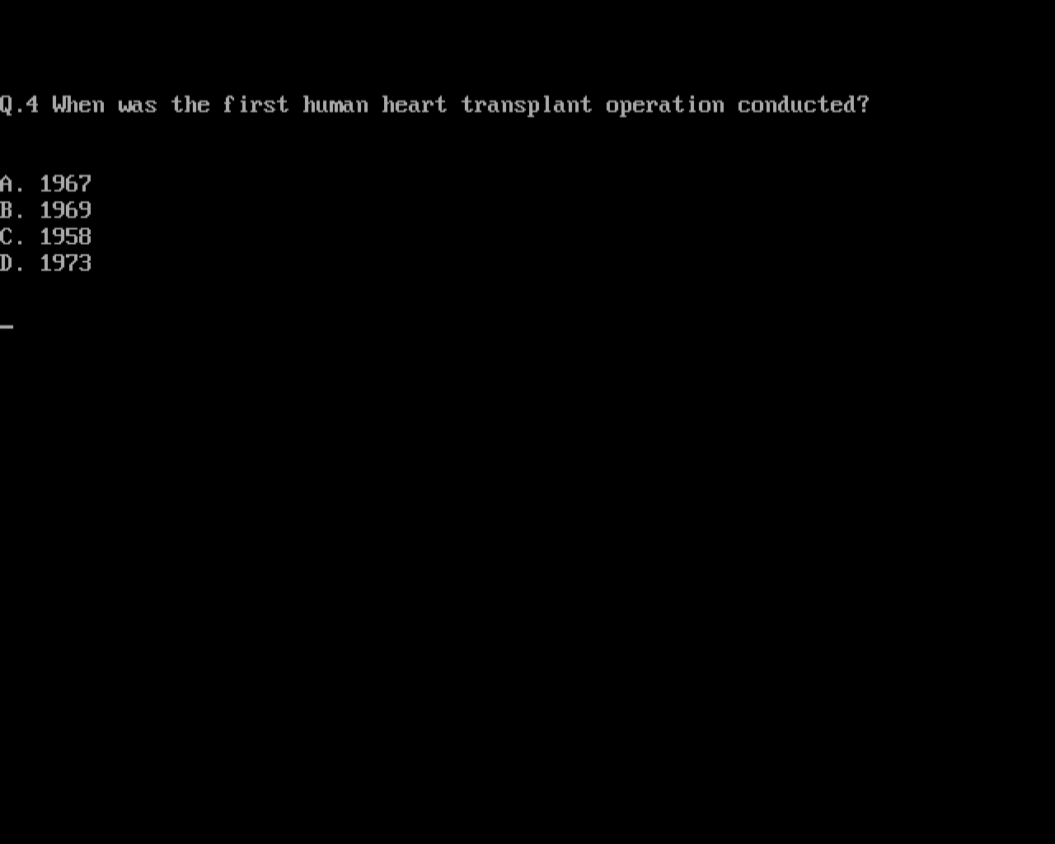
* 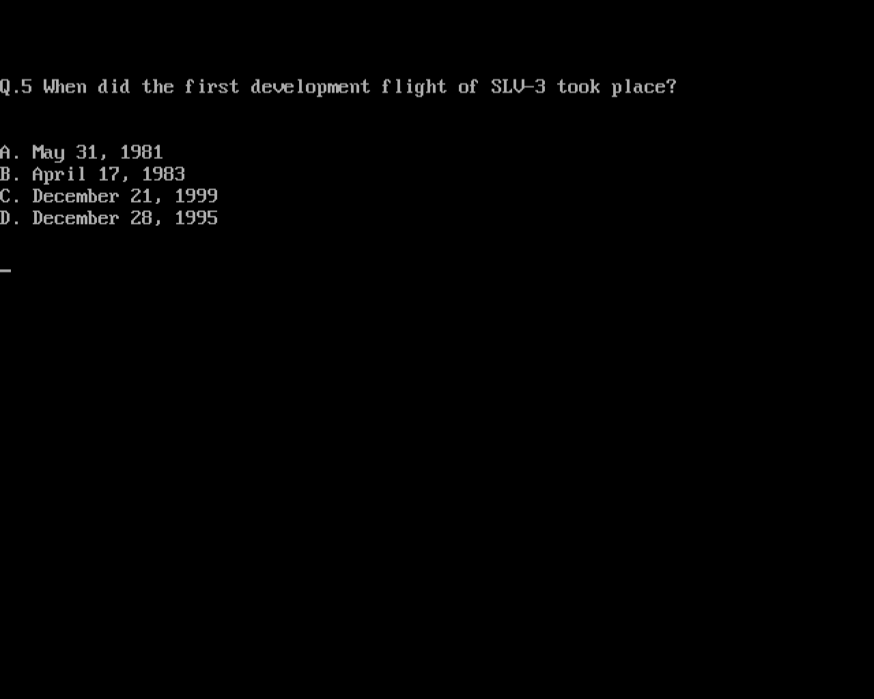
* 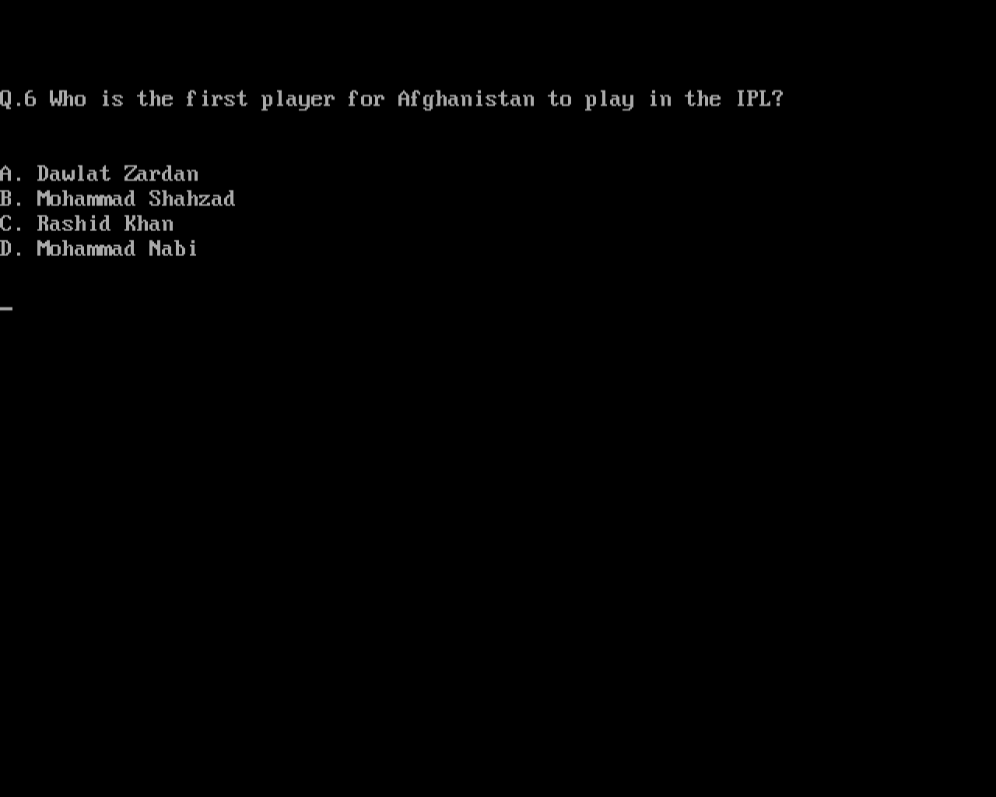
* 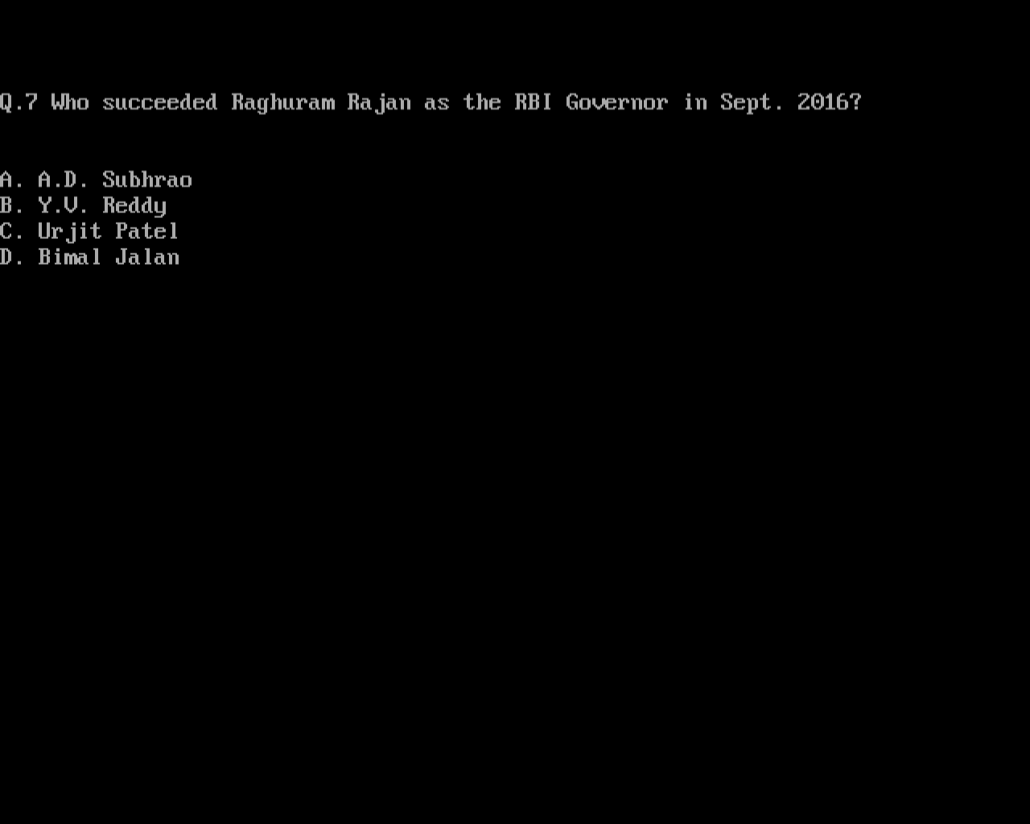
* 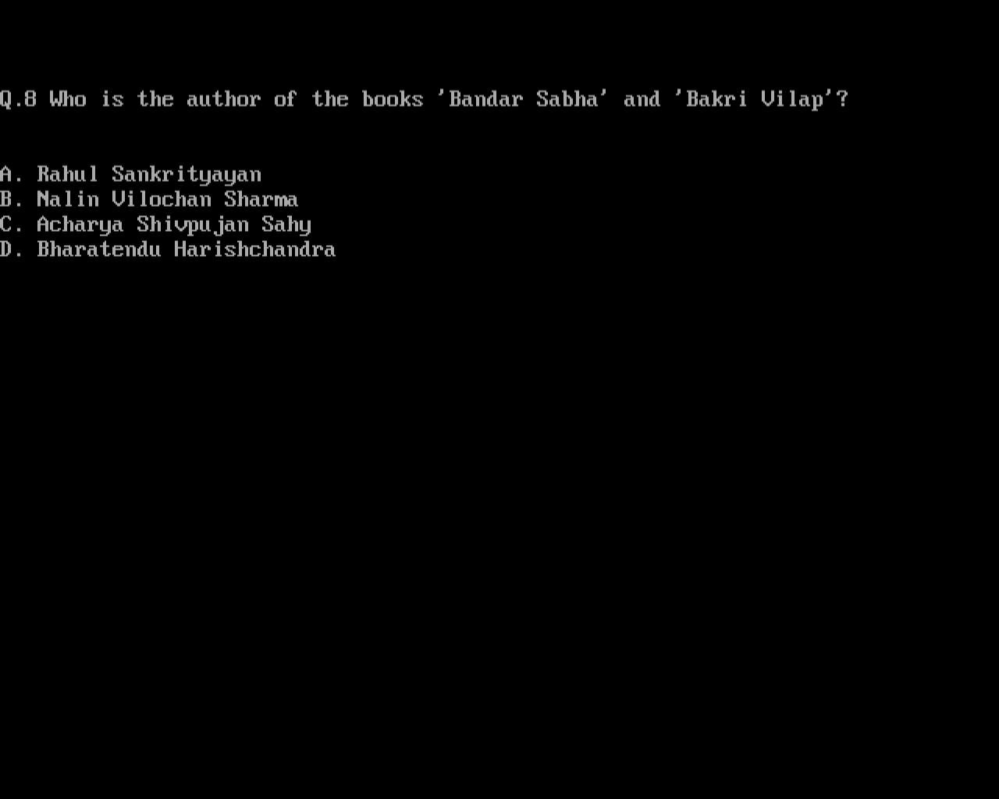
* 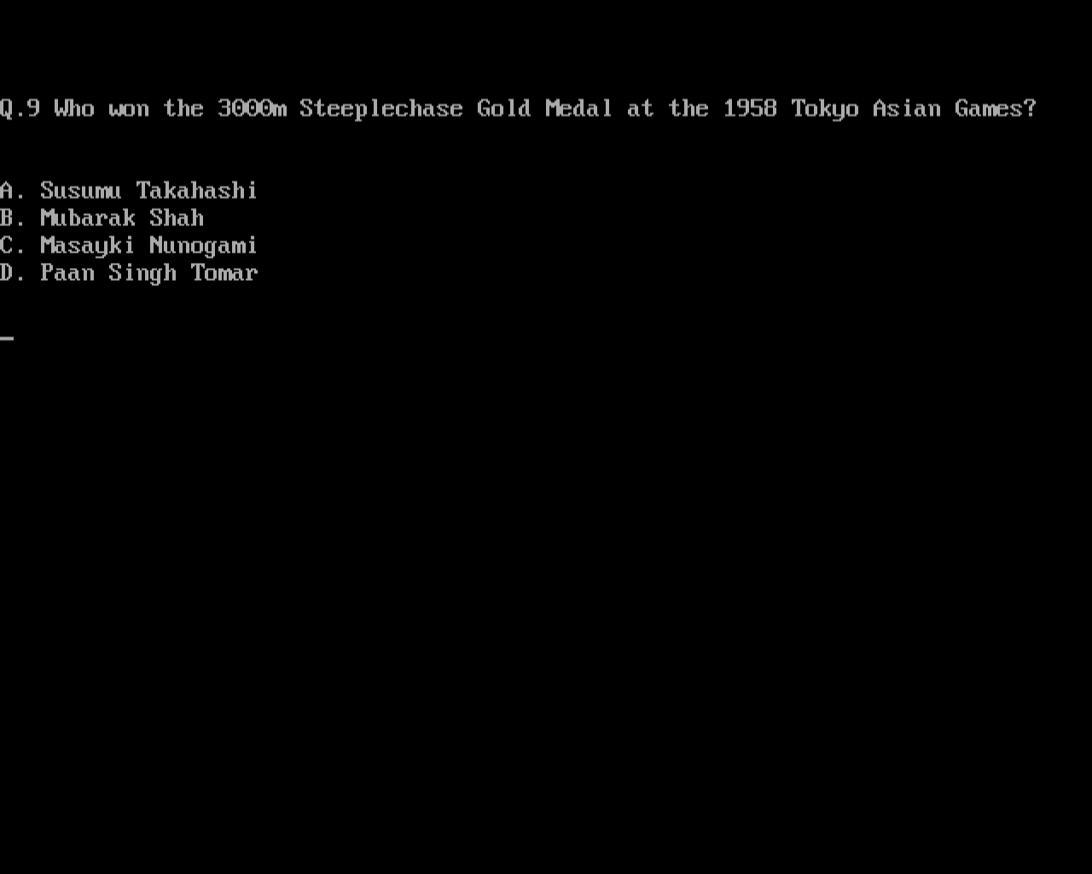
* 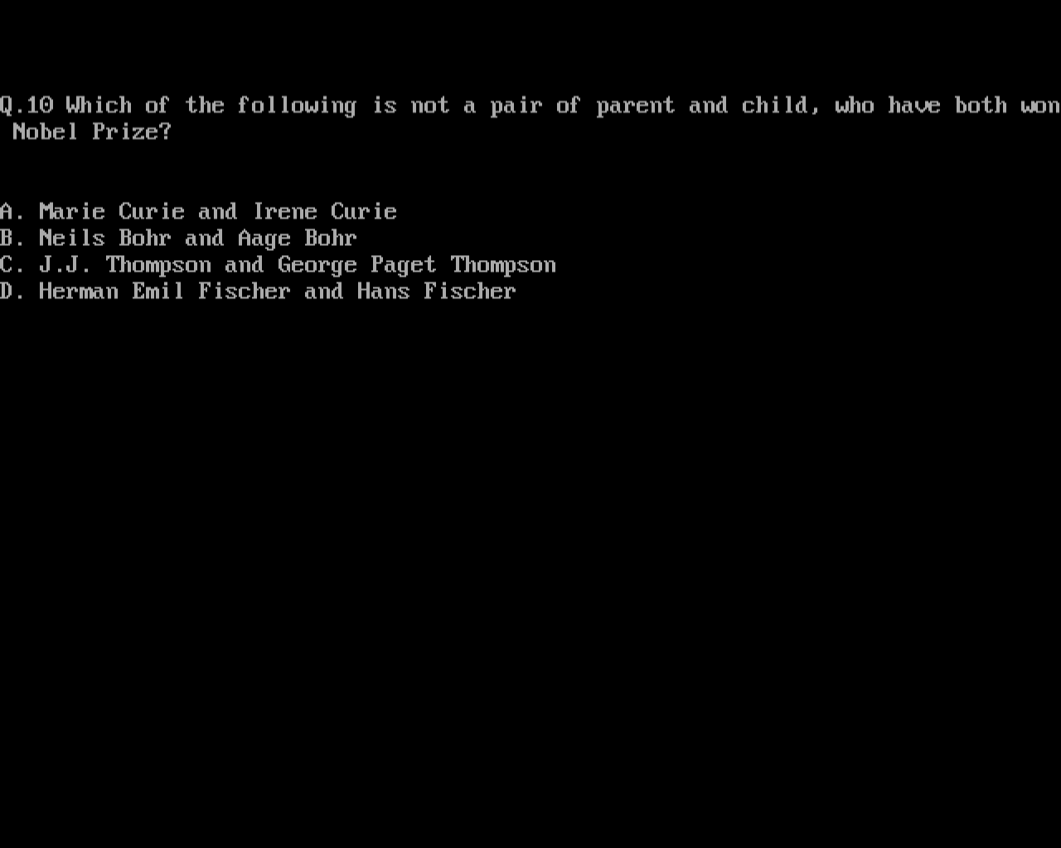
* 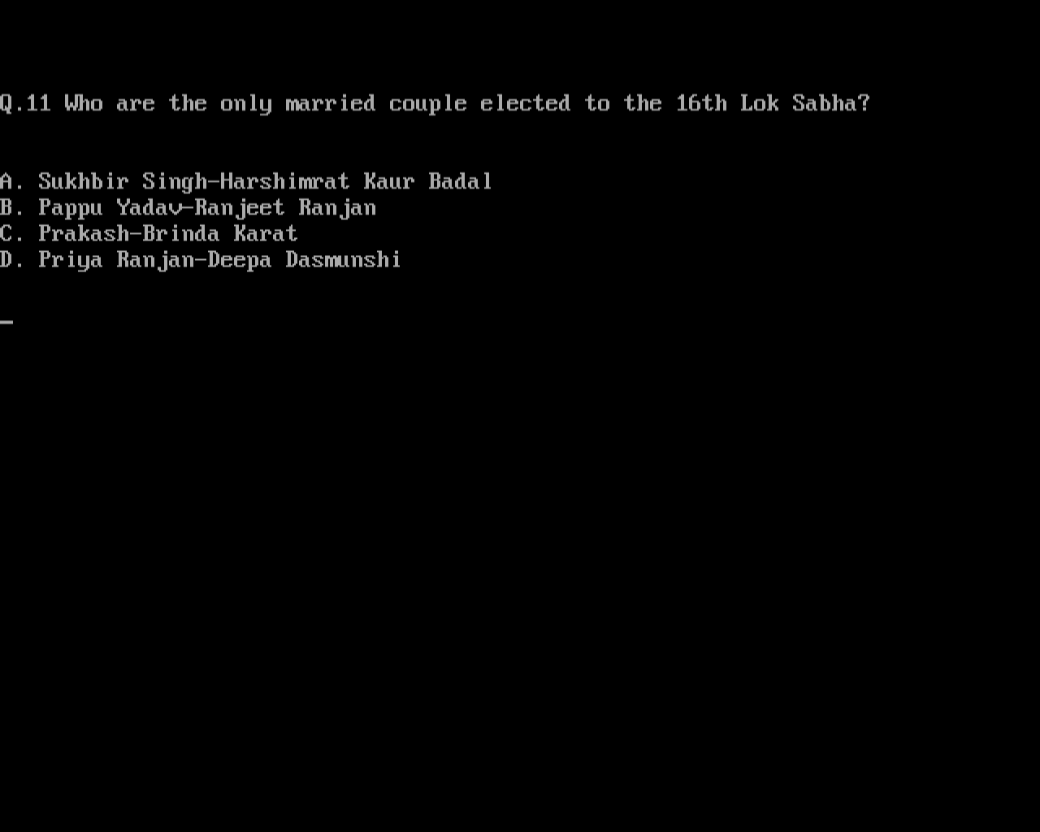
* 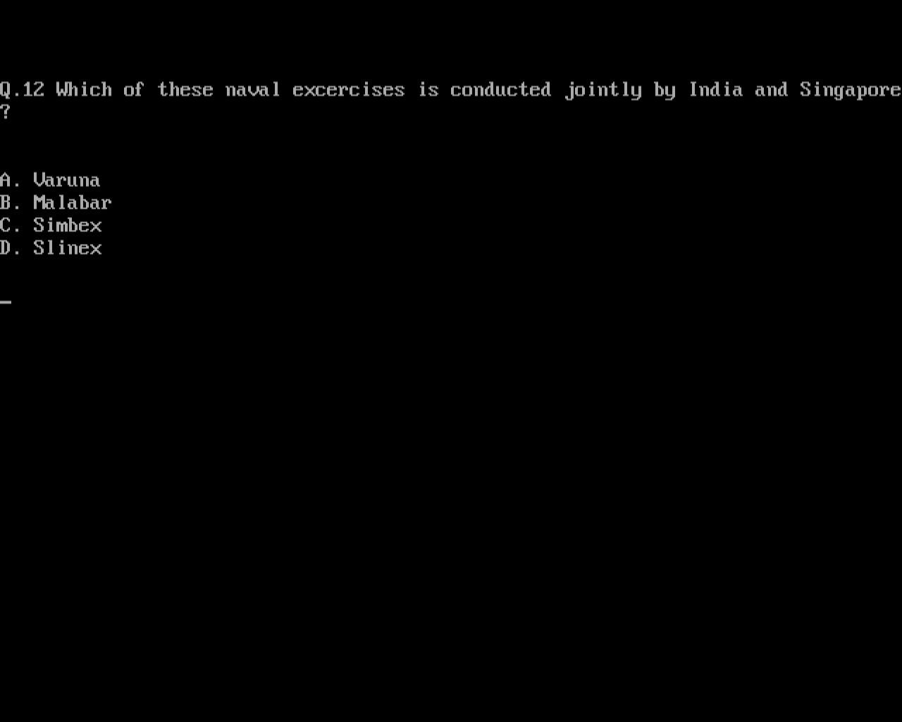
* 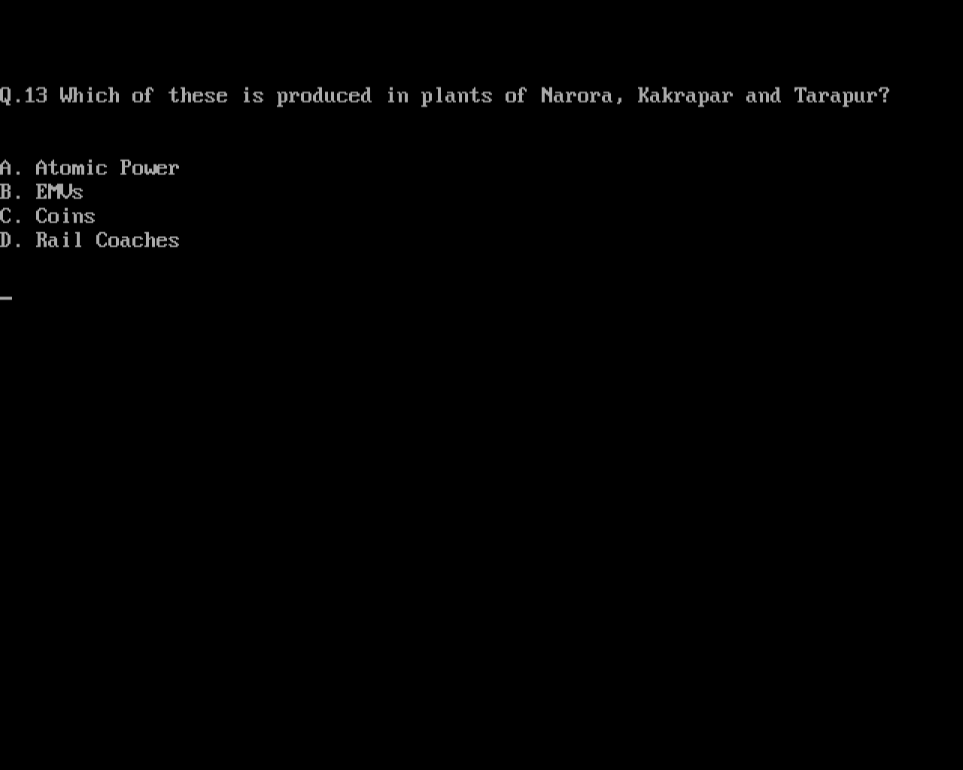
* 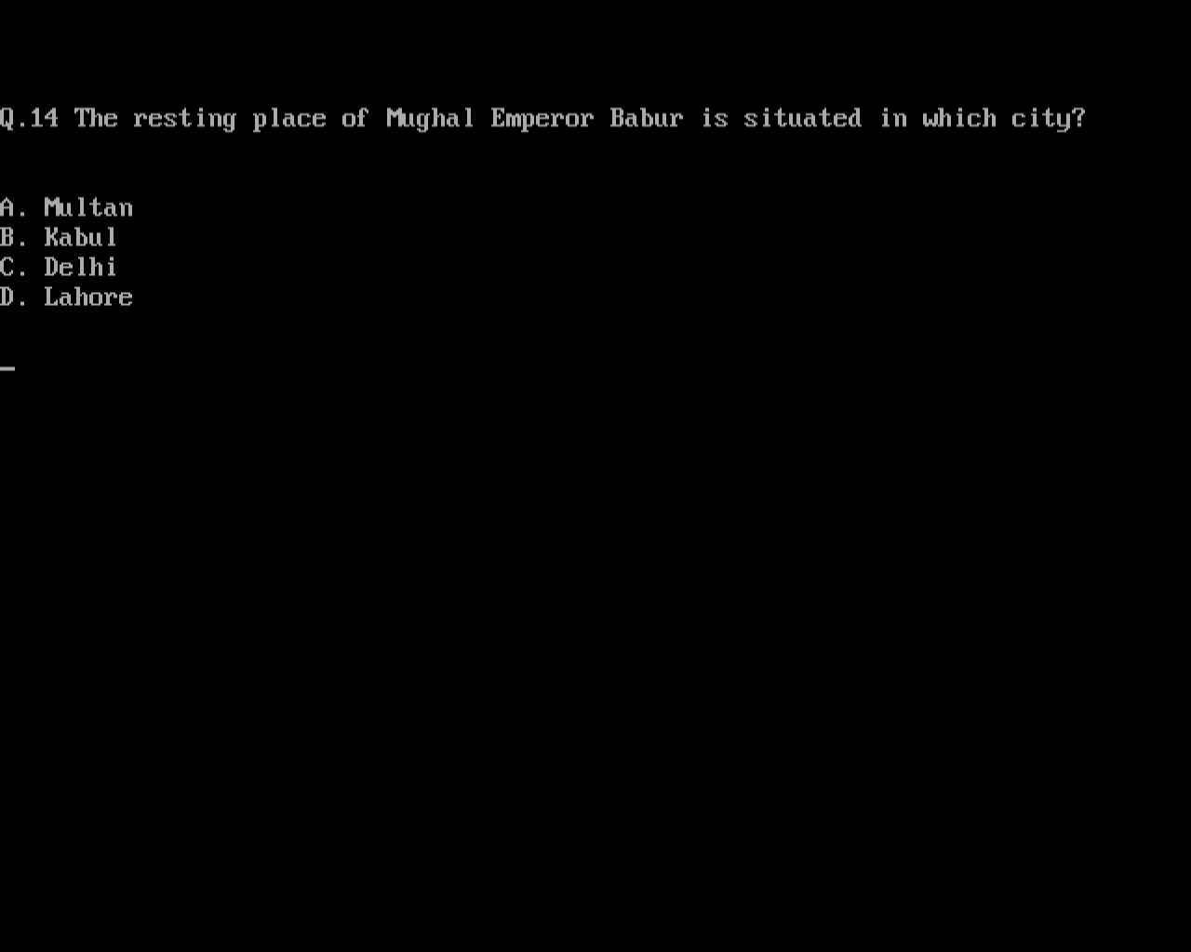
* 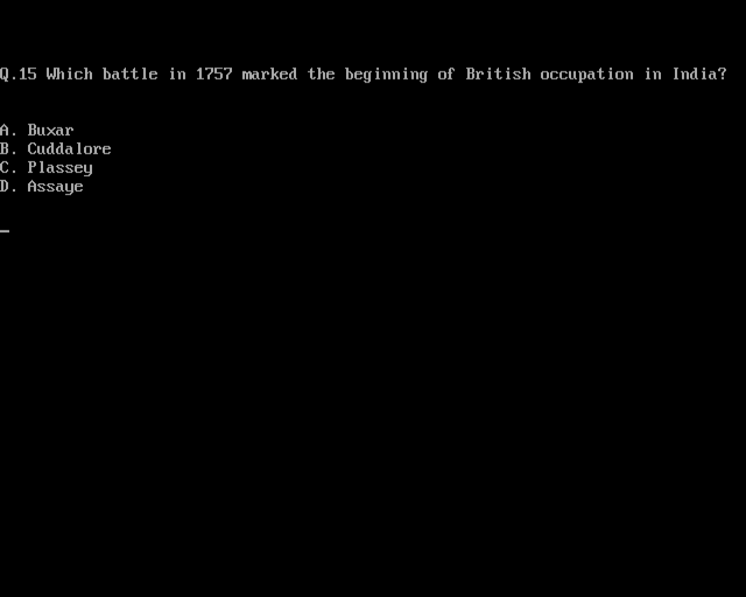
* 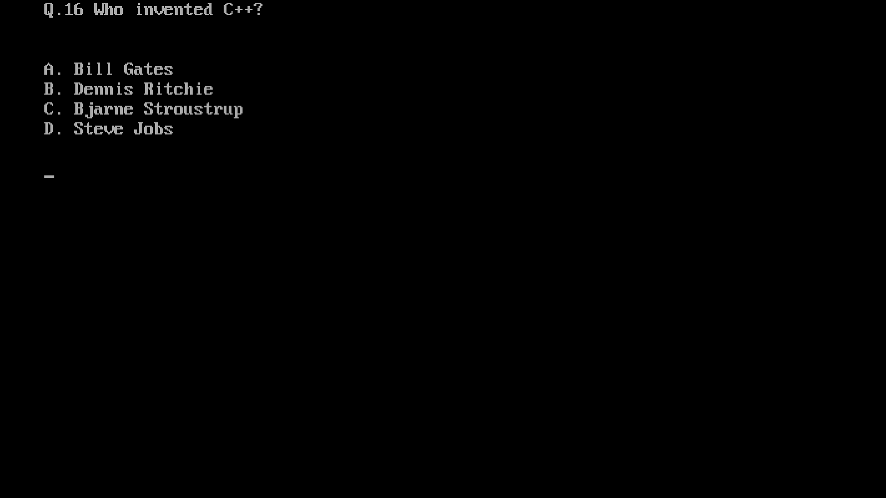

BIBLIOGRAPHY

We are highly indebted to these sources of information, that helped a lot to improve our project.

* https://stackoverflow.com/
* Computer Science with C++ Class XII Part I (By Sumita Arora)
* https://www.youtube.com/watch?v=kDLQzguicPQ